|  |
| --- |
| Project II Proposal |
| H-E-B  VENDOR MANAGEMENT SYSTEM |
| December 3  Authored by : Group 603-09 Mounica Tanikella Rakshit Soni Jasmine Sokhi Jash Thakkar |

**Contents**

Introduction 3

Stakeholders 4

Needs Analysis 7

User Stories 19

UML Diagrams 43

Class Diagrams 43

Entity-Relationship Diagram 54

Wireframes 55

Mockups 63

Project Plan 65

Sprint Plan 70

Implementation Plan 73

Introduction/Overview 73

Implementation description 74

Major rollout tasks & schedule 75

Pilot Program 76

Training plan 77

Discussion of user documentation 79

Transition from implementation to long term support 81

List of Contacts 84

# 

# Introduction

H-E-B is a private American chain of supermarkets from San Antonio, Texas. They own a total of 350 stores in the state of Texas in the U.S. as well as Northeast Mexico. It ranks 20th in the largest retailers in the United States.

This project is for H-E-B as a part of its expansion plan. H-E-B has been doing great with its 350 stores. However, they still have not covered the entire state of Texas. They plan on expanding to the East part of Texas, with first expanded branch opening up in Tyler, Texas. Expansion brings in the need of upgrading the current systems in terms of UI and storage and processing capacity.

H-E-B wants to partner with local vendors, manufacturers and farmers in order to be able to sell the local products as that has always been one of its special points of H-E-B. The purpose of this project is to create a vendor management system for HEB and help them expand to various parts of Texas and other states by identifying and understanding the various market regions demands and catering to an improved vendor management system.

This goes hand in hand with an upgraded inventory management system and will help in ease of communication with vendors, warehouses and help in predict the various trends in terms of what will/will not sell and what will be the future demand. We also plan to design a Quality Management system to test the quality of incoming products, decide on the expiry dates of the products and sell the only best to the customers.

# Stakeholders

**5 Most Important Stakeholders:**

* 1. **Customers**
     + Customers are the utmost important stakeholder because they are the entities which will be directly affected by the expansion of

H-E-B Stores

* + - They are the ones who will tell us about the local products which they prefer buying
    - The vendor management system should help us partner with many local vendors, manufacturers and farmers.
    - Without customers, the expansion efforts will not be successful, and the H-E-B business will not run
    - Customers share opinions and feedback which always help in deciding improvements and decide the turnover of customers
  1. **Local Vendors/Manufacturers/Farmers**
     + Local Vendors/Manufacturers/Farmers are the main stakeholders in this situation
     + They will be the ones partnering with H-E-B and selling their products with them
     + H-E-B will plan to target the advertisements and market themselves to these local vendors or manufacturers or farmer
     + The local products achieved from them will be sold to a larger customer base of H-E-B
     + The profits earned by H-E-B on selling the local products will be shared with the local vendors/manufacturers or farmers on the agreed percentage
  2. **H-E-B**
* H-E-B is the provider of the services to the customers and local vendors
* The local products sold by H-E-B will play a major role in expansion
* H-E-B will also take care of the quality of the products they sell
* H-E-B will also be responsible for an upgraded inventory management system which will serve the stores in the expanded locations in an efficient manner, ensuring the demand/supply chain
  1. **H-E-B Marketing team**
     + H-E-B Marketing team will be primarily responsible for identifying the local vendors, manufacturers and farmers
     + They will create marketing plans to involve the other stakeholders
     + They will send targeted advertisements to the local vendors in order to encourage them to become partners with H-E-B
     + They will be the primary handlers of the vendor management system
     + They will also handle communications with the current and future partners of H-E-B
  2. **H-E-B Quality Management Team**
* H-E-B Quality Management team will be the primary users of the upgraded Quality testing system
* They will be responsible for testing the quality of the incoming batch of local products
* Only after the tests are approved, the products will be available for sale
* They will assign a ‘Best by’ date for all the products by which they must be sold depending on the type and quality levels of the products

Other Stakeholders:

* 1. **Government**
* The government can play in role in thriving the relationships between H-E-B and local vendors, farmers and manufacturers encouraging them to be a partner with H-E-B and develop their businesses
  1. **Warehouse Owners**
* Warehouse Owners in the new areas can provide warehouse and various storage facilities to maintain the inventory for H-E-B
  1. **Transportation organizations**
* Transportation organizations can partner with H-E-B to provide delivery and logistics services in the expanded areas

# Needs Analysis

Customers:

1. **What are the top 3 local products which you want HEB to sell?**

Marks Spicy Salsa, Marks Steak Sauce, TeGar-den Farms Candied Jalapeño Peppers are top 3 products which should be sold by HEB

1. **What are the top 3 products available in other parts of Texas which you expect HEB to sell?**

HEB Borracho Beans made with Shiner Bock, Cafe Ole by H‑E‑B Houston Blend Taste of Texas Medium Roast Single Serve Coffee Cups and H‑E‑B That's Salsa Bout Texas Medium Salsa are three HEB products sold in other parts of Texas right now and we expect HEB to sell them in their new outlets as well.

1. **How convenient is it to obtain local products currently?**

We must travel to the limited outlets of the local vendors/manufacturers to buy the products.

1. **On a scale of 1-10, how expensive are local organic products sold by the farmers/manufacturers?**

The local organic products are a bit more expensive than bulk manufactured products, a 7/10 on the scale. However, they are of supreme quality and taste and people prefer buying them.

1. **How easily is the local produce available to you?**

Farmers bring in local produce every once a week to the nearest produce selling outlets and those products are available fresh only for that day as there are no storage facilities.

1. **If you face any issues with the local produce, how are they handled?**

We have not faced any issues with the local produce. But I feel there is no explicit place to record the issues or contact the appropriate person.

1. **How consistent is HEB with the local products throughout different outlets?**

Been to multiple outlets and the top local products are mostly available in different HEB outlets. However, the other products might not have the same consistency. At times, the restocking for the finished products if done after few days.

1. **What are your thoughts on the quality of the local produce in HEB?**

The main local produce is of really good quality and most of the people really like it. However, there are some products that can have more quality checks or at least more instructions on the durability.

1. **For flower product exclusively, what percentage cuts profit cuts would you give HEB?**

We can work the details case by case since there are many different species of plants that can be sold, some have more demand than others and that’s how we can decide the profit margin.

1. **Would you like to purpose ant marketing strategies other than what HEB already has in place?**

We would like the HEB site to have a link of our website so customer can understand the origin of the product and where it came for. Just a informational session would be good for now.

HEB:

1. **How can selling local products help HEB?**

To gain trust of customers in a new area, it is important for HEB to sell local products and become a part of their culture. This way HEB can attract more and more customers.

1. **How would HEB like to partner with local manufacturers?**

HEB would partner with the local manufacturers by providing a ground to sell their products to a larger customer base, gain more profits, provide storage and vendor management facilities and improve their sales by certain partner benefits.

1. What are some marketing strategies which HEB will use to partner with local manufacturers?

It is important for HEB to prove to the local vendors that they can be a useful medium of getting their products reach a larger customer base and a medium to earn more profits. HEB has attractive offers in place to encourage local vendors to partner with them and achieve a larger monetary gain from the partnership.

1. What will HEB do to ensure the quality of local products it plans to sell?

HEB plans to introduce new technologies to measure the quality level of the local products. HEB sells high quality products and will continue to do that. Tests will be run on every incoming load of products and then stored into the inventory.

1. What are some measures to improve vendor management?

HEB plans on migrating from the old vendor management system to a new one. Bigger servers and storage will be included to handle the expansion and inclusion of new vendors. The UI will be made for user friendly and intuitive. A monthly payment system will be set up to pay the profits to the local vendors on time.

1. What are some measures to improve inventory management?

HEB plans to partner with some local warehouse dealers and logistics companies to set up inventories at manageable distances from the stores. It also plans to partner with local delivery and transportation companies to smoothen the availability to products from inventory to stores.

1. What share of profits does HEB agree to pay to the local manufacturers?

HEB agrees to pay 40-70% of the profits to the manufacturers depending on the sales and various analytics which might differ from product to product.

1. What reservations does HEB have with local manufacturers?

We really do not have any reservations with the local manufacturers. We have always been very supportive and inclusive of the local products in our stores and do our level best to incorporate them. We have a significant chain of local products and would love to expand it to include more local manufacturers.

1. What is the conversion rate on your website for the local products?

We regularly check the conversion rate of various categories on our website. Currently the conversion rate for the local products is not as high as the other products. Currently it is 3.05% and would like to increase to more than 4.5%

1. **Does HEB use any kind of analytics to evaluate the usage and demand of local products?**

Yes, we do analytics for the website and our data. We perform intensive data analytics and also implement web analytics to optimize the website to generate more engagement as well as revenue.

1. **Did you have any bad customer experience with any particular local vendor?**

We did not have consistently bad experience with one particular vendor. At times, there are few bad feedbacks but that is a trend for other products too. If you are an ecommerce business, need to deal with bad feedback.

1. **How frequently do you incorporate new local products and review the existing ones?**

The review and shelving of new products happens once in a week, this is to maintain the count and make sure everything is in place. This is mostly automated.

1. **Would you sell weapons like guns and swiss knives?**

That will depend if we have approval from the government. However, even after that approval a good amount of background check of mental history and family history will be done before passing on to the customer.

1. **HEB has in store and delivery options for the customer, do you feel that there is any difference with demand for local vendors between the two mediums?**

We have noticed this over the period that the local produce sells more in our stores than online. Since customers can see the quality, they are more convinced to invest. However, our online numbers are also pretty good.

1. What is the communication flow for the new vendors who want to associate with HEB? What is the process?

There is a process, but it is not as elaborate as we would hope for. The local vendors reach us through email then our Customer Success team fixes a meeting to discuss all the requirements.

1. We can see that you have partnership programs for various sectors of local vendors, do you wish to add more?

Yes, we have some basic partnership programs, but they have not been upgraded for some time. Our team has been thinking of making the required upgrades.

Local Manufacturers/Vendors:

1. **What are your thoughts on selling your products in HEB?**

HEB is a huge brand. It will act as a ground to make profits, and have the local products reach out to a larger customer base. We would like to be a part of this and plan to revolutionize their products and company.

1. **Would you be able to make more profits?**

HEB can help us get our products to more and more customers. We can use their transportation and logistics model to have our products shipped to other parts of Texas. This is a great opportunity to earn profits which were never imagined.

1. **What are top 3 local products which are being sold the most?**

Local farm produce, Marks’ Sauces and TeGar-den Peppers and condiments are most sold by us currently.

1. **What margin of profits do you expect HEB to pay back?**

We expect more than 50% of profits from HEB. This could help us increase the production and reach more and more customers.

1. **How do you plan to split the profits with HEB on your sells?**

The profit will be split based on the amount of money earned. This will vary from vendor to vendor and product to product. HEB will at the least have 10% of every profit though.

1. **What do you feel about the quality testing process of HEB for the new vendors?**

The quality checks that our products need to pass is a lot. HEB believes in delivering the best product and they have different level of quality checks to make sure that the correct product is on the market.

1. As a new business, do you have any reservations in collaborating with HEB for business and why?

Collaborating with HEB would be a huge opportunity that would allow us to expand our business. It provides marketing of the products and helps small businesses in a significant way. They really do not pressure about the quantity, we as a vendor can decide our numbers.

1. When you first reached out HEB, was the process easy or did you face any delay in communication?

They did follow up on our request, but I feel the process could be smoother and more efficient.

Transportation Companies:

1. What sort of delivery methods would you consider for high efficiency?

The delivery method by planes would be the fastest, however for short distances we would prefer pickup trucks.

1. **Do you plan on buying any new trucks or pickup equipment?**

Not right now, however we have the budget to incorporate extra trucks if needed. The project will be giving us flexibility on that depending on the conditions, sales in the future.

1. **How would you tackle the issue of high traffic in the holiday season and catering to various vendors at far off locations?**

We would be using machine learning algorithms to understand the best path to take from HEB to marketplace and back.

1. **What is the number of the negative feedback you have faced because of late delivery?**

We have had some negative feedback because the order did not reach on time, but the numbers have decreased over a period of time.

1. **How frequently do you change the transportation agreements and review the routes?**

Our team constantly evaluates the agreements and does routine checks to make sure that we learn from our mistakes and add more measures to make it efficient.

Government:

1. How would you like to encourage the local vendors to sell their products in HEB?

HEB is a huge brand. It will definitely act as a ground to make profits, and have the local products reach out to a larger customer base. The government would like to encourage the local vendors to be a part of this and plan to revolutionize their products and company.

1. How would you encourage HEB to sell local products?

The government wants the local farmers, vendors and manufacturers to achieve the most from this partnership and progress their businesses. Hence, it will ensure that HEB pays the right profit to the local farmers, vendors and manufacturers.

1. **What special tax laws would come into picture when a company like HEB expands to other states?**

The company must obey the tax laws of both the home state and the expending state. This also depends on the kind of size of the HEB in the other state after it expands.

1. **Would you allow a market like HEB to sell weapons like guns and other artilleries of the same category?**

This again depends on the state gun control laws, if the state has provision then it can be sold, else not.

1. **Would you be regulating the company like HEB in terms of environment aspects and workforce dominance?**

The govt. will not interfere beyond what the law allows them to. However, if the conditions worsen like the environment degrades badly or proper measures are not taken then those are special conditions and will be investigated promptly.

1. **Are there any other special laws or guidelines that HEB and the vendors must take care of?**

HEB must hold to the required standards for its labour force and must at the same time cater to the tax and labour laws of that state.

1. **What kind of disputes have you faced with HEB in the past?**

We have not had any major disputes with HEB in the past. Usually there are small miscommunications which are sorted quickly by their team.

Warehouse Owners:

1. Would you like to partner with HEB and if yes how?

HEB is a powerful brand in some parts of Texas. Considering the feedback from the current warehouse dealers and logistics firms who have partnered with HEB, we would like to partner with them too. We can provide our warehouses for storage and delivery and help them improve their inventory.

1. What measures can you suggest improving inventory management for HEB?

Our warehouses currently are equipped with the latest technology to handle inventory in a smooth way. We also provide facilities for storing pharmacy, cold storages and easy to access loading hubs to load the trucks in a very efficient and quick way.

1. What are your thoughts about becoming the middle party between HEB and local manufacturers?

We think that is a great idea. We plan to be on a commissioned plan where we can introduce the local vendors who are our clients to HEB and gain commission on both of them for every partnership. We could also provide storage grounds to both of them which could flourish their relationships.

1. **How do you plan on handling the extra workload that will be coming from new vendors?**

We will be applying better algorithms to understand the prediction and usability of the product so we can improve the efficiency of our delivery.

1. **How would you deal with shortage of employees when extra vendors ship their product?**

We generally allow shifts for people in the warehouse here. They can have flexible work hours. And that is why we have many employees already. We also plan to automate a lot of work so workers need not do the repetitive task and that will save their time.

1. **How does HEB respond to your new implementation techniques?**

They are pretty accommodating with the requests, but we do have to follow the standard protocols that they have been assigned.

1. What kind of reservations have HEB added for the warehouse owners?

There is no such restriction that HEB has other than their protocols. If we have any problems, then we can reach out and they try their best to work with us.

1. As a warehouse owner, are you exclusively working for HEB or you have the flexibility to house our products too?

We can work with other products too but in the HEB clause there are certain considerations that need to be upheld for this to happen. These clauses make sure that there is no mix-up and if the warehouse can meet the criteria then they can house other products.

Real Estate:

1. What would be the best place to open an HEB market in the city of Houston?

This depends on local competition; it can be a few blocks away or near a mall that is heavily visited by the people.

1. **How would you select the location of the warehouses?**

We can select the warehouse depending the distance of the local vendors who are shipping to HEB and select a most feasible central point that would be near to all.

1. **Are there any standards for building such commercial buildings that must be followed by law or we can make buildings as we like?**

Once the land is acquired, we have the freedom to make the building as we want however, we need to cater to the laws and safety guidelines for making a building by the state govt.

1. **How much does HEB believe in investing a new store? Do they prefer to build from scratch or use the existing structure?**

HEB believes in starting from the foundation of the building so that the structure is compliant to the standard norms and there are no violations.

1. How does HEB look for real estate? Do they hire third party consulting firms or have in house team for this?

HEB has associations with third party consulting groups that do proper analytics and based on the heuristics provide a well-suited place for the store.

1. What differences do you feel with real estate hunting in a small city in comparison to big well-developed city?

It is much easier as well as economic to build in the small city because of the real estate value. However, the bigger cities have more resources and work is done quickly.

1. What kind of issues has HEB faced in the past with respect to real estate?

HEB has encountered some roadblocks in the past which have hindered the opening of the store for that particular place. Our team now does proper analysis before considering the property.

1. What parameters do HEB have to follow for the quality testing real estate?

We have a different set of guidelines for the quality testing of the products. We need to follow rules that are permitted by law so that there is no harm to the environment. Therefore, the location of the quality testing estates is usually in the outskirts of the town.

Competitors (Walmart):

1. How many local manufacturers/farmers sell their local products with you?

As competitors we cannot reveal the numbers, but we do have relationships with a good number of local vendors.

1. Is it easy to convince the manufacturers/farmers to sell their products with a brand like yours?

Brand name is very useful. However, gaining the trust of the local vendors is extremely important along with being fair in agreements and partnership clauses.

1. What are different marketing strategies adopted by your companies to partner with the locals?

We are not able to reveal our strategies to our competition. But HEB current strategies are pretty good.

1. On a scale of 1-10, how has the response of local customers on purchasing local produce from your stores?

On a scale of 10, the score for local customers producing local produce from the stores is 8.

1. On a scale of 1-10, how profitable has it been for your stores to sell local products?

On a scale of 10, the score for profitability by selling local products in our stores is 7.

1. **Do you incorporate any new technologies for the local vendors?**

We do have good level of technologies for all the vendors that we have in the business. We have not updated any technical updates in technology specific to local vendors

1. Do you face more quality issues with local vendors in comparison to the bigger brands?

We cannot mention the exact statistics but percentage wise I can say that it is near. It depends which kind of brands we have associated during that period.

# User Stories

User Story 1: Local Customer

I am a local customer in Tyler, Texas. I want to buy local products of my choice. I need to know the different products available in HEB and filter to find local products. I need to browse through the promotional offers available on the products. I need to look through the various available delivery slots. I need to place the order and make the payment with the option of my choice. I need an email or mobile confirmation to be sent after placing the order. I want the information regarding the scheduled delivery.

Actor:

* Customer
* HEB Personal Shopper

Stakeholder:

* HEB

Primary Actor:

* Customer

Preconditions:

* The list and description of the products must be on the system
* The Customer’s email and contact details must be on the system

Triggers:

* The Customer plans to visit HEB website and wants to go to buy local products

Main Success Scenarios:

* Customer views the different products, filters options based on the type of local product they want to buy, looks through the product description, prices and ratings, find offers on the product, finds time slots for delivery on dates they want to choose, places an order and makes a payment, receives an email and text confirmation, has the information regarding scheduled delivery

Success Factors/Acceptance Criteria:

* The Customer can view all the different products
* The Customer can filter through the products based on the type of local product they want to buy
* The Customer can look through the ratings, prices and description of the products
* The customer can look through the promotional offers on the products
* The Customer can look through the various delivery slots
* The customer can place the order and make the payment with the option preferred by the customer.
* The Customer can receive an email and text notification of the confirmation
* The scheduled delivery can be added to the Customer’s calendar

Alternative Paths:

* The system is not able to send email confirmations due to some technical error
* Products are not showing up in the list
* Promotional Offers are not made available by the HEB manager
* The system is not able to sync the Customer’s calendar and add the scheduled delivery

Use Case Diagram:

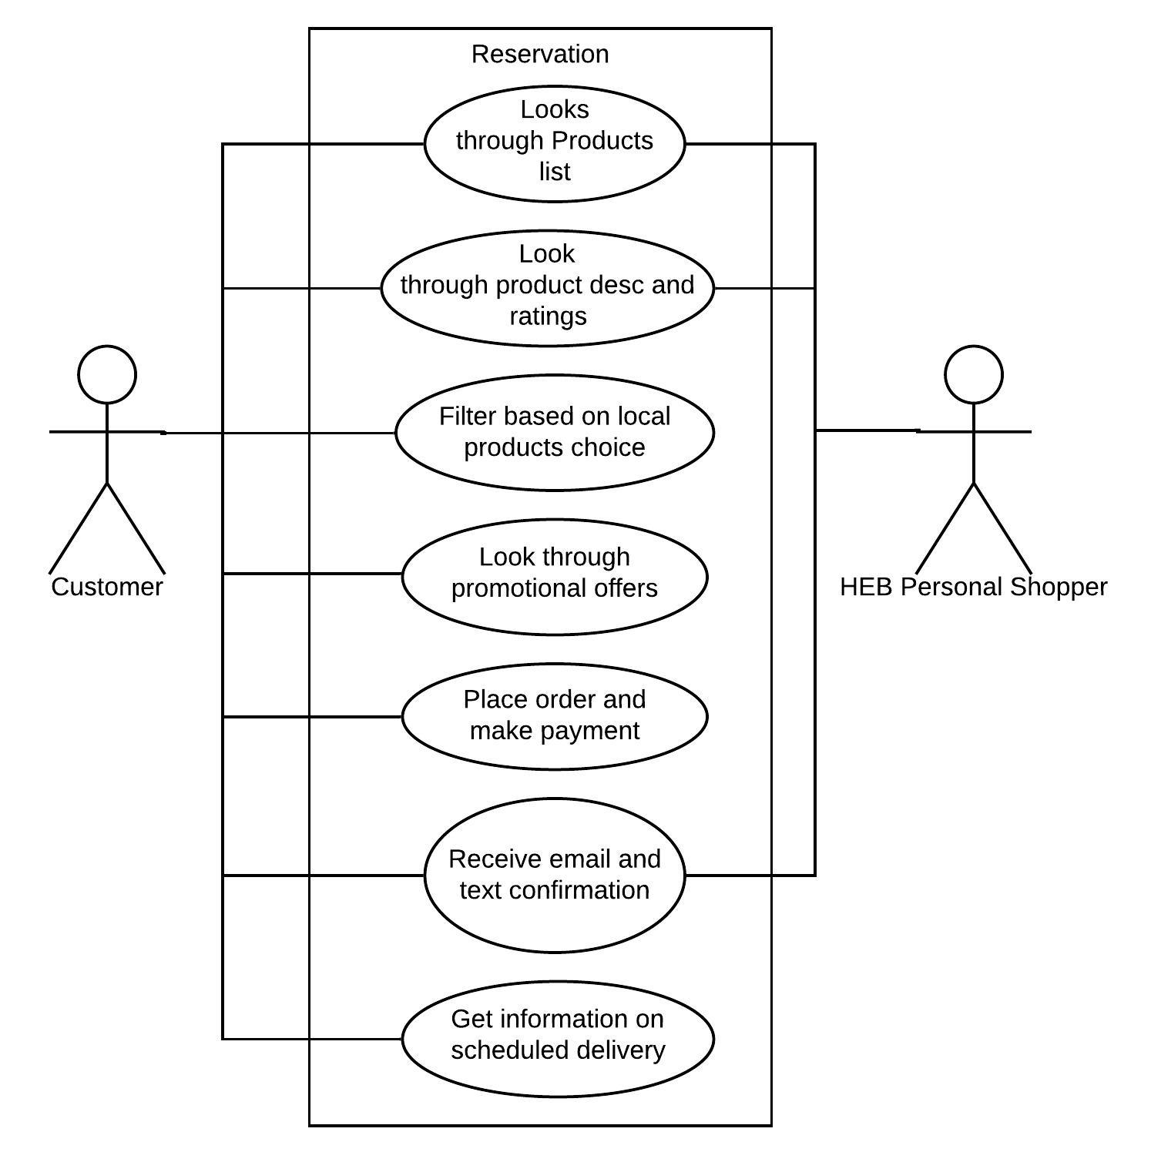

User Story 2: Member of HEB Marketing team

I am a member of the HEB Marketing team. I want to market various strategies to local vendors, farmers and manufacturers of Tyler, Texas. I want to use marketing advertisements to attract more and more local vendors for which they can register with us. I want to display various partnership plans with the vendors. I want to be able to publicize our most important vendors or products to help the local companies grow their business.

Actor:

* Member of HEB Marketing Team
* Local Vendors, Farmers or Manufacturers

Stakeholder:

* HEB
* Business Owners
* Customers

Primary Actor:

* Member of HEB Marketing Team

Preconditions:

* The list of the partnership plans must be on the system
* The HEB team’s contact details must be on the system
* The vendors’ information must be available on the system

Triggers:

* The Member of HEB Marketing team wants to publicize and attract more and more local vendors, farmers or manufacturers for the partnership
* Sponsors want to invest in the event and want to publicize their businesses

Main Success Scenarios:

* The HEB Marketing team publicizes the partnership opportunities with posters or ads, sends target advertisements to the local vendors, farmers and manufacturers, lets vendors register as partners, responds to vendors for various partnership information, publicizes the important partners and their products to help them increase their business

Success Factors/Acceptance Criteria:

* The HEB Marketing team member can publish ads and posters
* The HEB Marketing team member can send target advertisements to local vendors, farmers and manufacturers
* A local vendor, farmer or manufacturer can register as a partner
* The HEB Marketing team member can post the partnership information on the website
* The sponsor can look through various partnership options and contact the HEB Marketing team member
* The HEB Marketing team member publicizes the local vendor’s business and products on the system

Alternative Paths:

* The system is not able to post posters or ads due to some technical glitch
* Target advertisements email system is not working properly
* The registration link is not working properly
* Partnership information is not available to the vendors
* The system is not able display the vendors’ ads or products

Use Case Diagram:

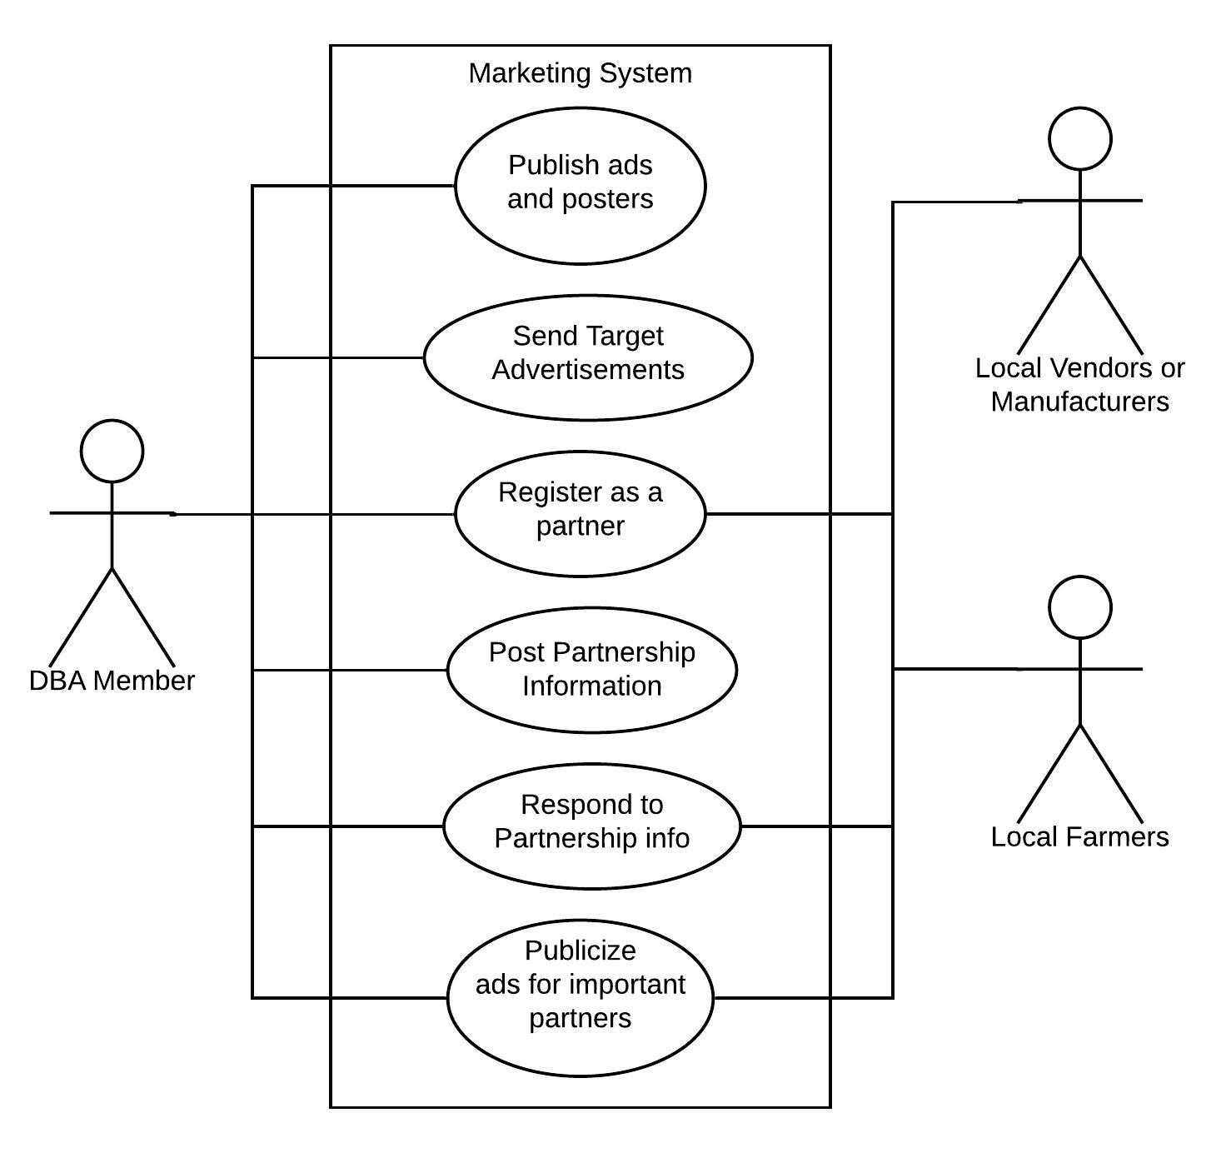

User Story 3: Member of HEB Inventory Management Team

I am a member of the HEB Inventory Management team. I want to look through the available inventory quickly. I want to be able to search and filter through products or vendors. I should be notified when the stock of a certain product goes below threshold. The vendor should be notified if their stock goes below threshold. I need a real time connection of the inventory system with the stores to gauge the sales and update inventory accordingly.

Actor:

* Member of HEB Inventory Team

Stakeholder:

* HEB
* Local Vendors

Primary Actor:

* Member of HEB Inventory Team

Preconditions:

* The list of products must be on the system
* Vendor details should be available on the system

Triggers:

* The member of the HEB Inventory Management team wants to look through the available inventory quickly. The member and the vendor want to be notified when the stock of a certain product goes below threshold.

Main Success Scenarios:

* The member of the HEB Inventory Management team looks through the available inventory quickly. The member and the vendors get notified when the stock of a certain product goes below threshold.

Success Factors/Acceptance Criteria:

* The member of HEB Inventory team can look through the products in the inventory
* The member of HEB Inventory team can filter through the products and vendors in the inventory easily
* The member of HEB Inventory team can get notified when the stock of a certain product goes below threshold.
* The vendors can get notified when the stock of a certain product goes below threshold.
* The member of HEB Inventory team can have a real time connection between the stores and Inventory

Alternative Paths:

* The inventory management application is not working efficiently
* Products are not showing up on the system
* The notification system does not work properly
* The connection between stores and inventory goes down

Use Case Diagram:

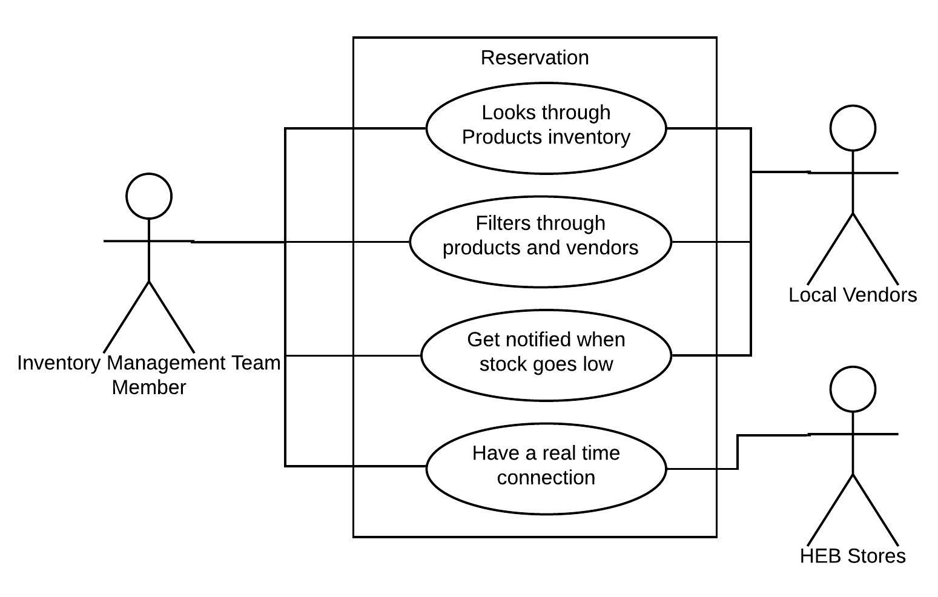

User Story 4: Local Vendor/Manufacturer

I am a local vendor/manufacturer. I want to be able to go through the HEB Partnership norms. I want to be able to register as a partner on the portal. I want to be able to receive feedback from current partners of HEB and learn about their benefits. I want to be able to coordinate the delivery of my products on time to HEB. I want to be able to receive monthly payments and profits of the products sold to HEB.

Actor:

* Local Vendor/Manufacturer
* HEB

Stakeholder:

* Current Partners

Primary Actor:

* Local Vendor/Manufacturer

Preconditions:

* The list of current partners must be on the system
* Registrations for partners should be available on the system

Triggers:

* The local vendor/manufacturer wants to partner with HEB

Main Success Scenarios:

* The local vendor/manufacturer goes through the HEB Partnership norms. They register as a partner on the portal. They receive feedback from current partners of HEB and learn about their benefits. They coordinate the delivery of my products on time to HEB. They receive monthly payments and profits of the products sold to HEB

Success Factors/Acceptance Criteria:

* The local vendor/manufacturer can go through the HEB Partnership norms
* The local vendor/manufacturer can register as a partner on the portal
* The local vendor/manufacturer can receive feedback from current partners of HEB and learn about their benefits
* The local vendor/manufacturer can coordinate the delivery of my products on time to HEB
* The local vendor/manufacturer can receive monthly payments and profits of the products sold to HEB

Alternative Paths:

* Partnership norms are not showing up on the system
* The registration link for partners goes down
* The payment system stops functioning due to a technical glitch
* There is a problem in coordinating with the delivery

Use Case Diagram:

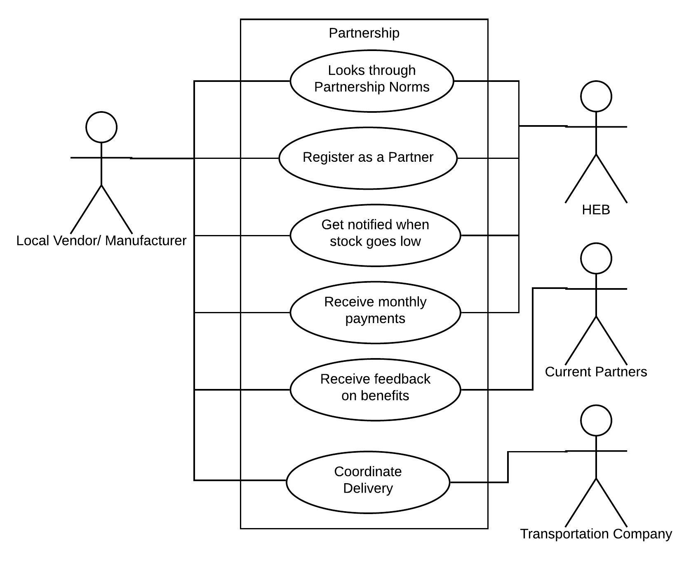

User Story 5: Local Farmer

I am a local farmer. I want to be able to go through the HEB Partnership norms. I want to be able to register as a partner on the portal. I want to be able to receive feedback from current partners of HEB and learn about their benefits. I want to be able to coordinate the delivery of my farm produce every week to HEB. I want to be able to receive monthly payments and profits of the farm produces sold to HEB

Actor:

* Local Farmer
* HEB

Stakeholder:

* Current farmer partners

Primary Actor:

* Local Farmer

Preconditions:

* The list of current partners must be on the system
* Registrations for partners should be available on the system

Triggers:

* The local farmer wants to partner with HEB

Main Success Scenarios:

* The local farmer goes through the HEB Partnership norms. They register as a partner on the portal. They receive feedback from current partners of HEB and learn about their benefits. They coordinate the delivery of my farm produce every week to HEB. They receive monthly payments and profits of the farm produces sold to HEB

Success Factors/Acceptance Criteria:

* The local farmer can go through the HEB Partnership norms
* The local farmer can register as a partner on the portal
* The local farmer can receive feedback from current partners of HEB and learn about their benefits
* The local farmer can coordinate the delivery of my farm produce every week to HEB
* The local farmer can receive monthly payments and profits of the farm produces sold to HEB

Alternative Paths:

* Partnership norms are not showing up on the system
* The registration link for partners goes down
* The payment system stops functioning due to a technical glitch
* There is a problem in coordinating with the delivery

Use Case Diagram:

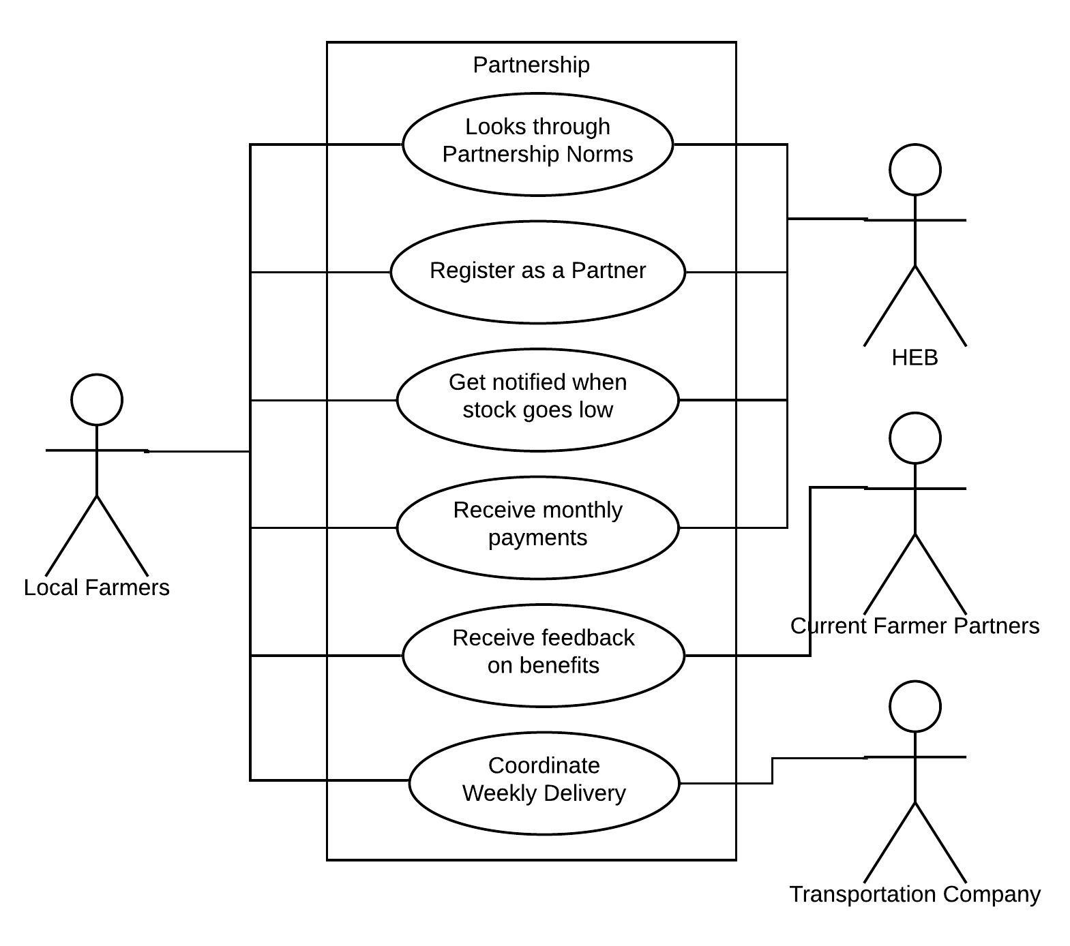

User Story 6: Member of HEB Quality Testing Team

I am a member of HEB Quality Testing team. I want to be able to test the quality of products in a span of 15 mins. I want to be able to receive the results of the test on my quality dashboard. I want to be notified if the product fails a quality test. I want to be able to email the quality reports to the vendor of the products. I want to generate ‘Best by’ labels based on type of product and level of quality.

Actor:

* Member of HEB Quality Testing team

Stakeholder:

* Vendors

Primary Actor:

* Member of HEB Quality Testing team

Preconditions:

* The list of products arriving must be on the system
* Required quality levels for each type of products should be available on the system

Triggers:

* The Member of HEB Quality Testing team wants to test the quality of the arriving products

Main Success Scenarios:

* Member of HEB Quality Testing team tests the quality of products in a span of 15 mins. He/she receives the results of the test on his/her quality dashboard. He/she is notified if the product fails a quality test. He/she can email the quality reports to the vendor of the products. He/she generates ‘Best by’ labels based on type of product and level of quality.

Success Factors/Acceptance Criteria:

* Member of HEB Quality Testing team can test the quality of products in a span of 15 mins
* Member of HEB Quality Testing team can receive the results of the test on his/her quality dashboard
* Member of HEB Quality Testing team can be notified if the product fails a quality test
* Member of HEB Quality Testing team can email the quality reports to the vendor of the products.
* Member of HEB Quality Testing team can generate ‘Best by’ labels based on type of product and level of quality.

Alternative Paths:

* Arriving Products are not showing up on the system
* The quality testing takes more than 15 mins
* The report emailing system goes down
* The quality portal goes down

Use Case Diagram:

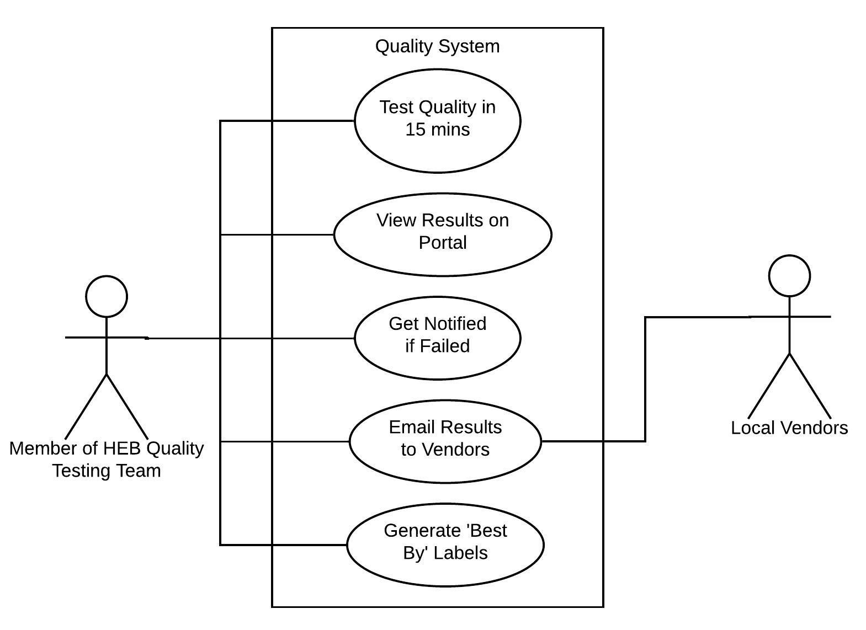

User Story 7: Warehouse Manager

I am a warehouse manager. I want to see the incoming batch of products of a particular day on the portal. I want to route the batch of products to the right section of the warehouse. I want to automate the routing of products to be dispatched from the warehouse to the pickup trucks. I want to receive notifications of delays and send an email to HEB. I want to receive monthly warehouse rent payments from HEB.

Actor:

* Warehouse Manager
* HEB Manager

Stakeholder:

* HEB
* Warehouse Owners

Primary Actor:

* Warehouse Manager

Preconditions:

* The list of warehouse sections must be on the system
* The list of incoming and outgoing batch of products must be on the system

Triggers:

* The warehouse manager wants to manage storage of incoming and outgoing batch of products

Main Success Scenarios:

* Warehouse manager sees the incoming batch of products of a day on the portal. He/she routes the batch of products to the right section of the warehouse. He/she can automate the routing of products to be dispatched from the warehouse to the pickup trucks. He/she receives notifications of delays and sends an email to HEB. He/she receives monthly warehouse rent payments from HEB

Success Factors/Acceptance Criteria:

* The warehouse manager can see the incoming batch of products of a day on the portal.
* The warehouse manager can route the batch of products to the right section of the warehouse.
* The warehouse manager can automate the routing of products to be dispatched from the warehouse to the pickup trucks.
* The warehouse manager can receive notifications of delays
* The warehouse manager can send an email to HEB about delays.
* The warehouse manager can receive monthly warehouse rent payments from HEB

Alternative Paths:

* Incoming Batches are not showing up on the system
* The status of warehouse section does not show up on the system
* Delay Reporting system stops working

Use Case Diagram:

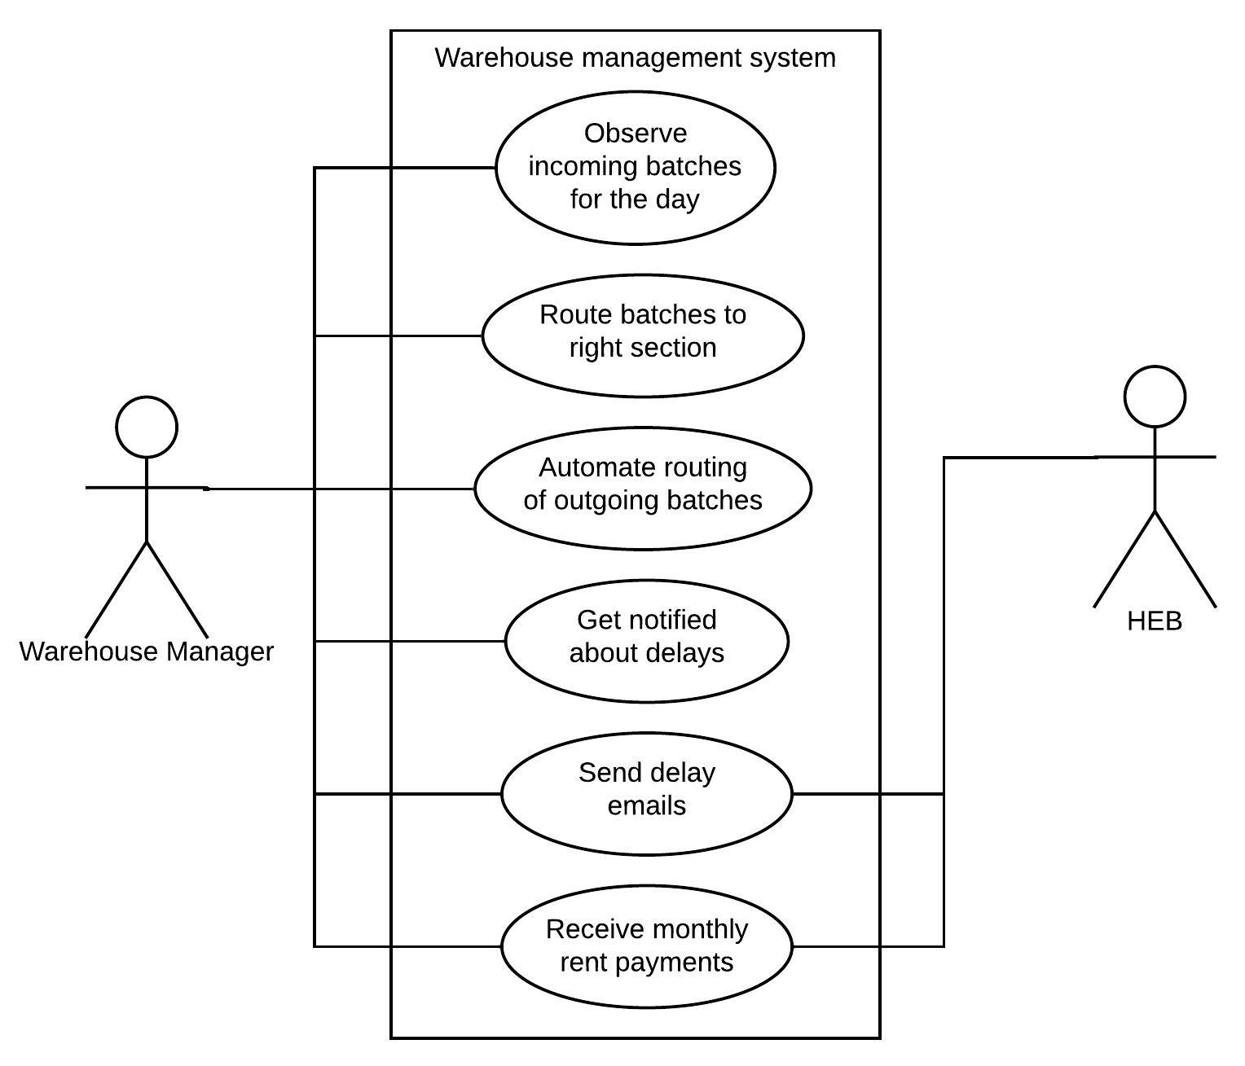

User Story 8: Manager of Transportation Company

I am a Manager of the transportation company. I want to schedule deliveries from vendors to warehouses. I want to receive notifications for requirements of products in the stores assigned to my company. I want to schedule deliveries from warehouses to the stores. I want to track my trucks which are on way to deliveries. I want to get notified about delays in the delivery.

Actor:

* Manager of transportation company

Stakeholder:

* Transportation Company
* Warehouses
* HEB Stores
* Local Vendors

Primary Actor:

* Manager of transportation company

Preconditions:

* The requirements of products must be on the system
* The delivery routes must be on the system

Triggers:

* The manager of transportation company wants to efficiently manage the supply and demand of products between vendors, warehouses and HEB stores

Main Success Scenarios:

* Manager of the transportation company schedules deliveries from vendors to warehouses. He/she receives notifications for requirements of products in the stores assigned to his/her company. He/she schedules deliveries from warehouses to the stores. He/she tracks my trucks which are on way to deliveries. He/she gets notified about delays in the delivery.

Success Factors/Acceptance Criteria:

* The manager of the transportation company can schedule deliveries from vendors to warehouses
* The manager of the transportation company can receive notifications for requirements of products in the stores assigned to his/her company
* The manager of the transportation company can schedule deliveries from warehouses to the stores
* The manager of the transportation company can track my trucks which are on way to deliveries
* The manager of the transportation company can get notified about delays in the delivery.

Alternative Paths:

* The system is not able to send delay notifications due to some technical error
* Product demands are not showing up in the list
* The system is not able to sync the delivery schedules

Use Case Diagram:

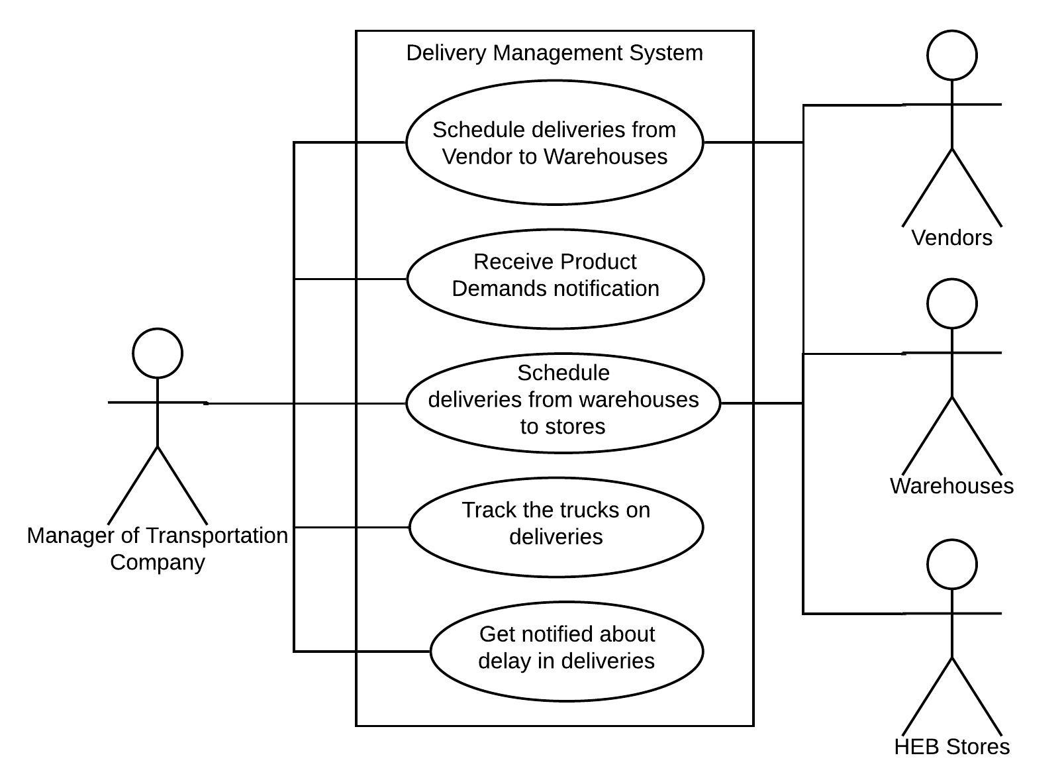

# UML Diagrams

## **Class Diagrams**

DIAGRAM 1: USE CASE DIAGRAM:

The main actors in our system are:

* Customer
* HEB Marketing Team member
* Local Vendor/ Farmers/Manufacturer
* Member of HEB Inventory Team

The top use cases for our system are:

The customer wants to buy local products of his choice. He needs to know the different products available in HEB and filter to find local products. He needs to browse through the promotional offers available on the products and look through the various available delivery slots. He also needs to place the order and make the payment with the option of my choice. He needs an email or mobile confirmation to be sent after placing the order.



DIAGRAM 2: ANALYSIS CLASS DIAGRAM

**I have considered the following set of requirements for designing a class diagram for parking lot**

* The customer can buy the local products of his choice. He should be able to filter the products based on requirements. He should see the home delivery slots and make payment accordingly.
* HEB Marketing Team should be able to strategize the marketing plan, create effective advertisements, create partnership plans with vendors.
* The transportation company should schedule the deliveries from vendors to warehouses, receive requirement notifications, schedule deliveries from warehouses to the stores and track delivery trucks
* The quality testing team should test the quality of products, receive the results of the test, notify if the product fails quality test and give best buy labels
* The local vendors should be able to register on the portal, receive feedback, coordinate the delivery to HEB and receive monthly payments
* The inventory manager should be able to look through the inventory, search and filter the products and notify when the stock goes down.

The classes that are included are:

* Manager of Transportation Company
* HEB Quality Testing Team
* Local Vendors
* Inventory Manager
* Customer
* HEB Marketing Team

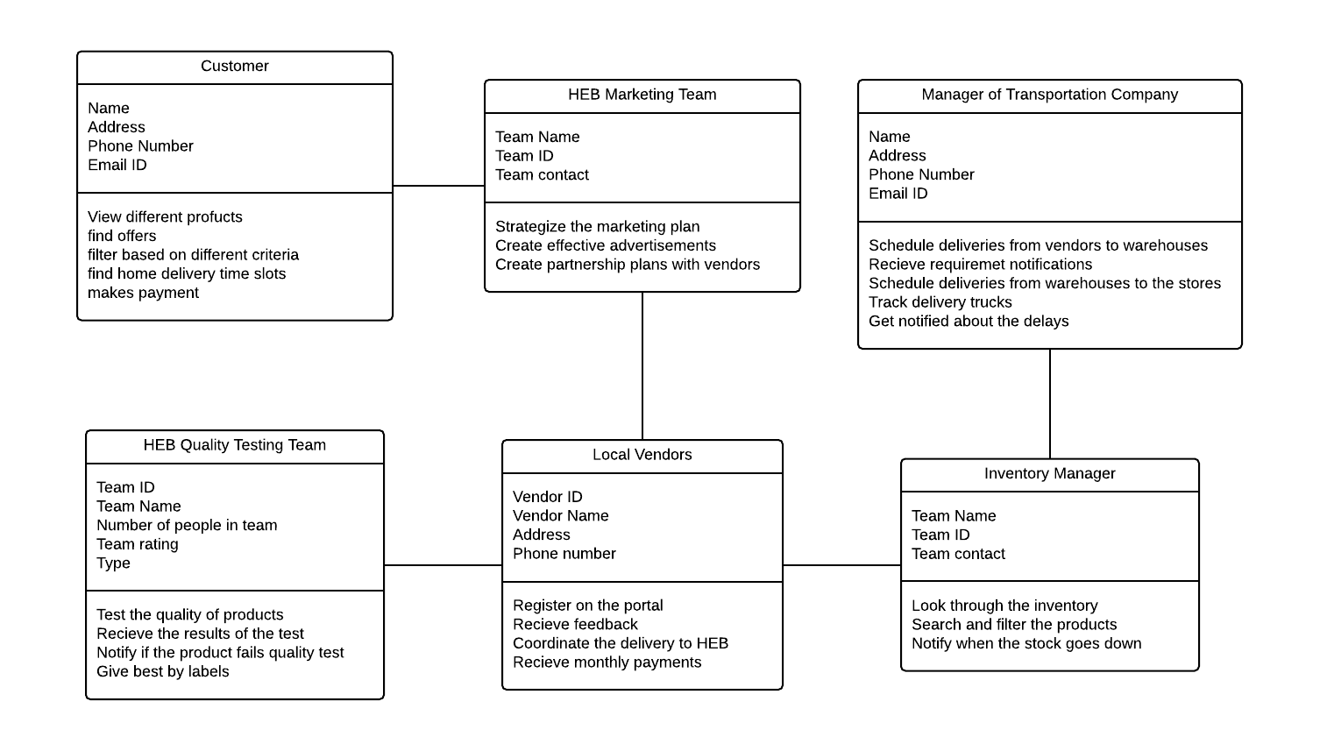

DIAGRAM 3: ACTIVITY DIAGRAM

The below figure depicts an activity diagram for a HEB Vendor Management system. Once a local vendor registers on the portal, he wants to sell his new product. From there the product goes to the quality testing team. If it fails the test, the feedback is sent to the vendor back so that he can improve his product for the next time. If it passes the test, it goes to the local transportation company to schedule for deliveries from vendor to the warehouse. The warehouse manager registers the new product in the inventory. Then the marketing team markets the product to the customers. The customer makes the payment and sends feedback.

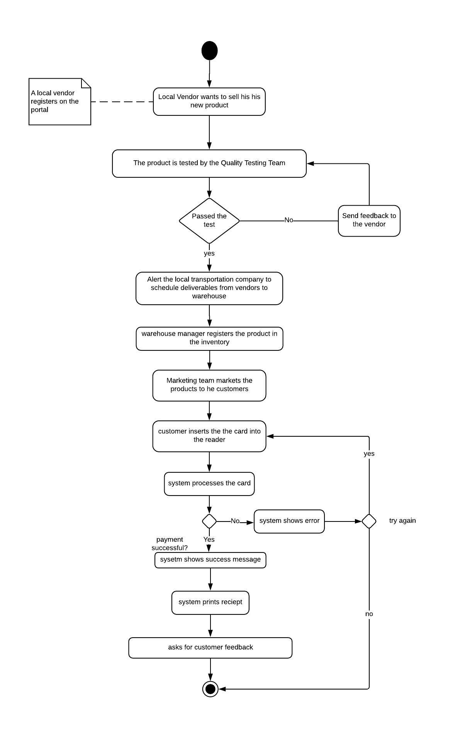

DIAGRAM 4: STATE DIAGRAM

The below figure depicts a state diagram for a HEB Vendor Management system. Once a local vendor registers on the portal, he wants to sell his new product. From there the product goes to the quality testing team. If it fails the test, the feedback is sent to the vendor back so that he can improve his product for the next time. If it passes the test, it goes to the local transportation company to schedule for deliveries from vendor to the warehouse. The warehouse manager registers the new product in the inventory. Then the marketing team markets the product to the customers. The customer makes the payment and sends feedback.

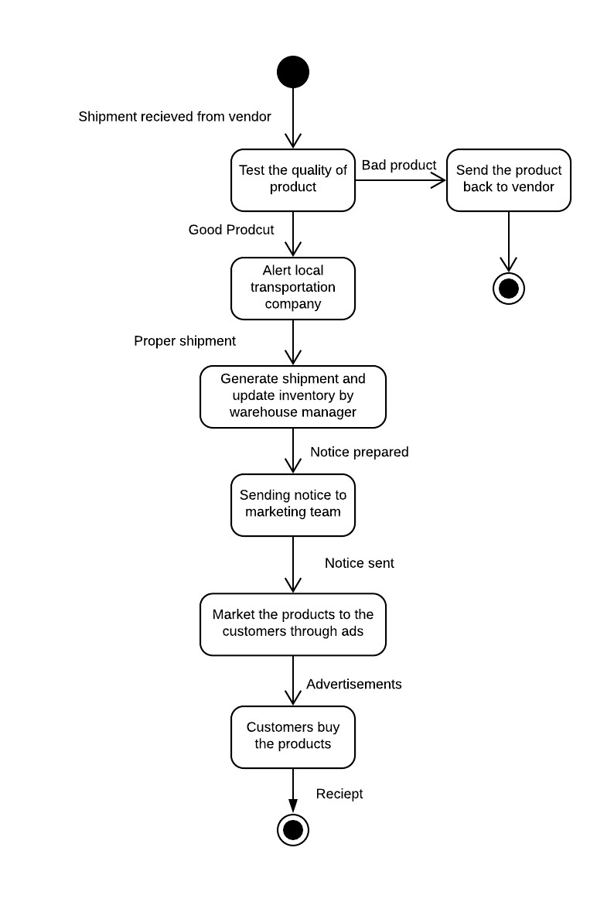

DIAGRAM 5: DESIGN CLASS DIAGRAM

**I have considered the following set of requirements for designing a class diagram for parking lot**

1. The customer can buy the local products of his choice. He should be able to filter the products based on requirements. He should see the home delivery slots and make payment accordingly.
2. HEB Marketing Team should be able to strategize the marketing plan, create effective advertisements, create partnership plans with vendors.
3. The transportation company should schedule the deliveries from vendors to warehouses, receive requirement notifications, schedule deliveries from warehouses to the stores and track delivery trucks
4. The quality testing team should test the quality of products, receive the results of the test, notify if the product fails quality test and give best buy labels
5. The local vendors should be able to register on the portal, receive feedback, coordinate the delivery to HEB and receive monthly payments
6. The inventory manager should be able to look through the inventory, search and filter the products and notify when the stock goes down.

**The classes that are included are:**

1. Manager of Transportation Company
2. HEB Quality Testing Team
3. Local Vendors
4. Inventory Manager
5. Customer
6. HEB Marketing Team

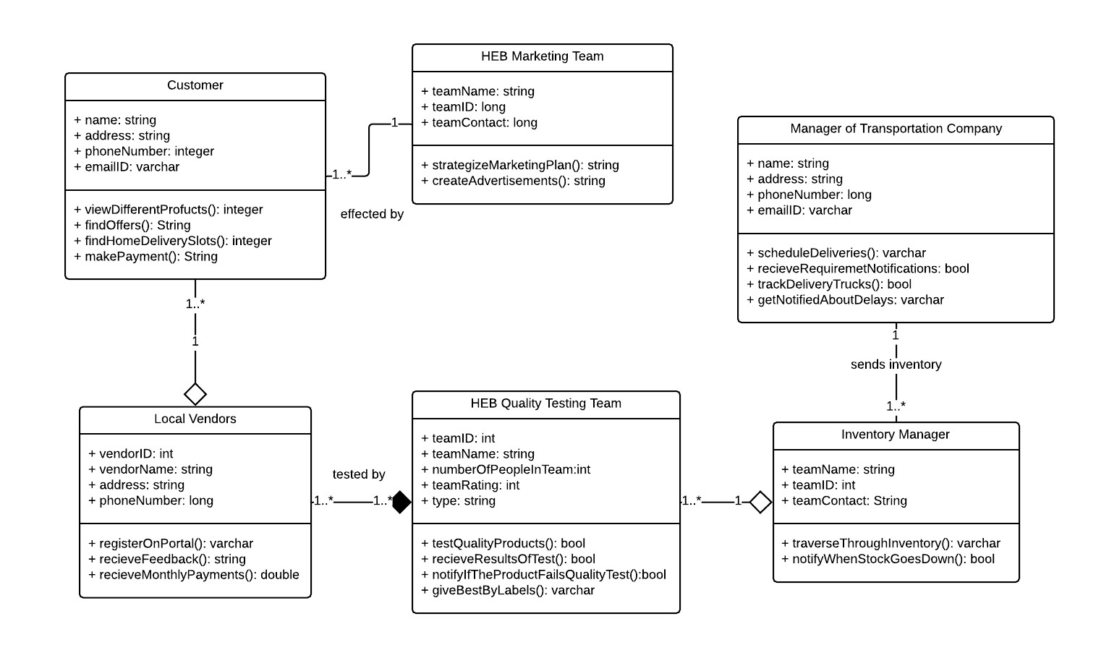

DIAGRAM 6: SEQUENCE DIAGRAM

Different synchronous and asynchronous messages are flowing between the states. There are several reply messages. Here firstly the local vendor provides the products to the quality testing team and they are given feedback. If the quality team approves the products, it sends it to the transportation team. From there it is sent to the inventory, where the manager registers the product in the inventory. The marketing team handles the strategies of HEB to vendors in the form of ads and take the inputs from vendors to market the products to the customers. The customers do the payment.

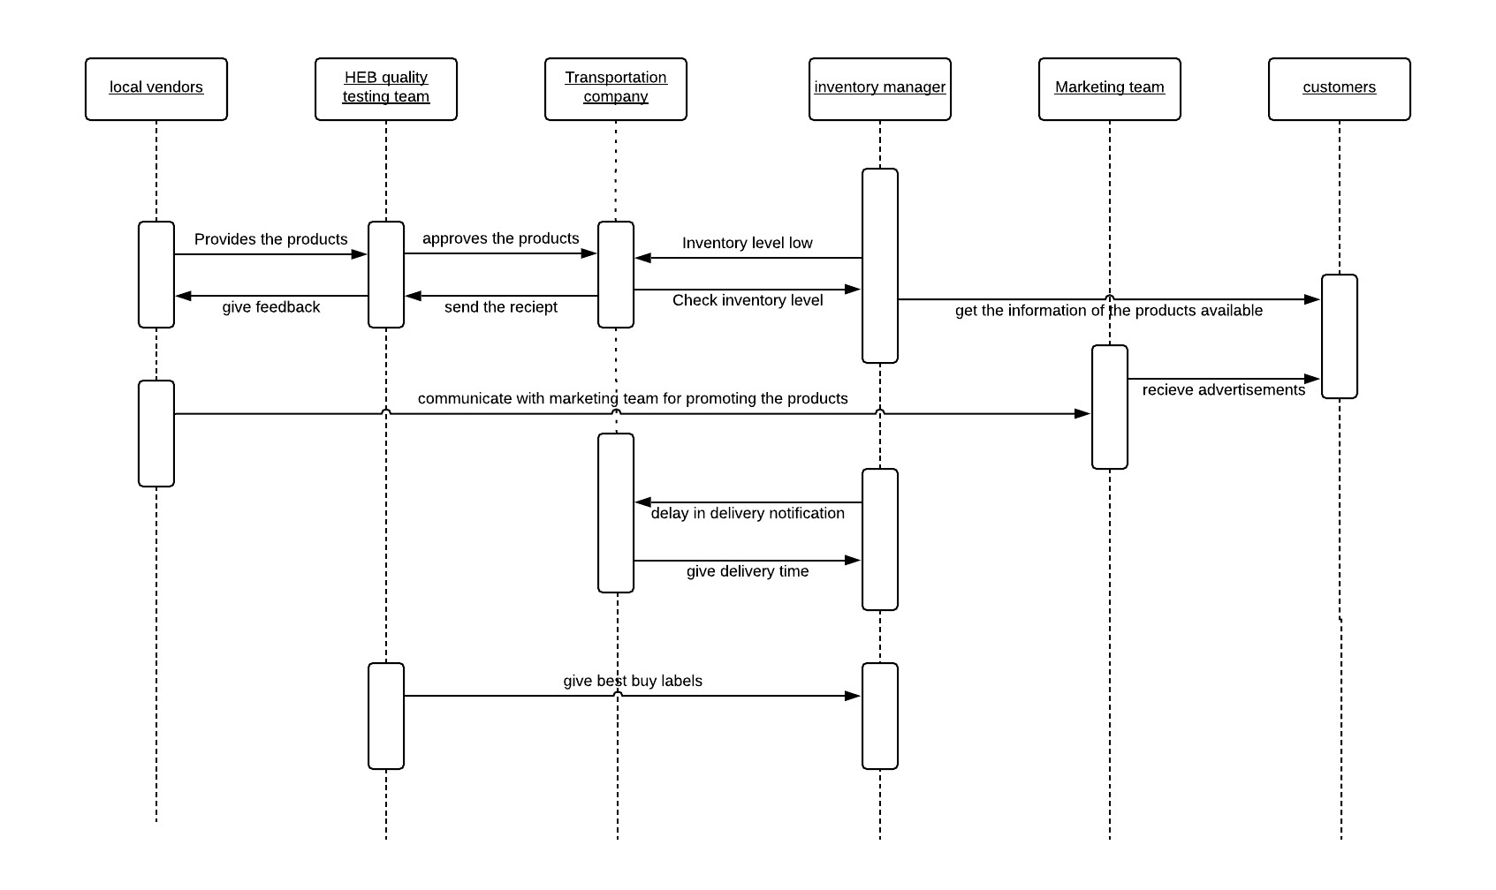

DIAGRAM 7: PACKAGE DIAGRAM

There are 5 different packages. They are order, quality management, inventory, vendor. The has order class and database table as sub packages. The Inventory has inventory class and specification as sub packages. They are as a part of inheritance hence are written in the same package. The vendor package has vendor class and database table as sub packages.

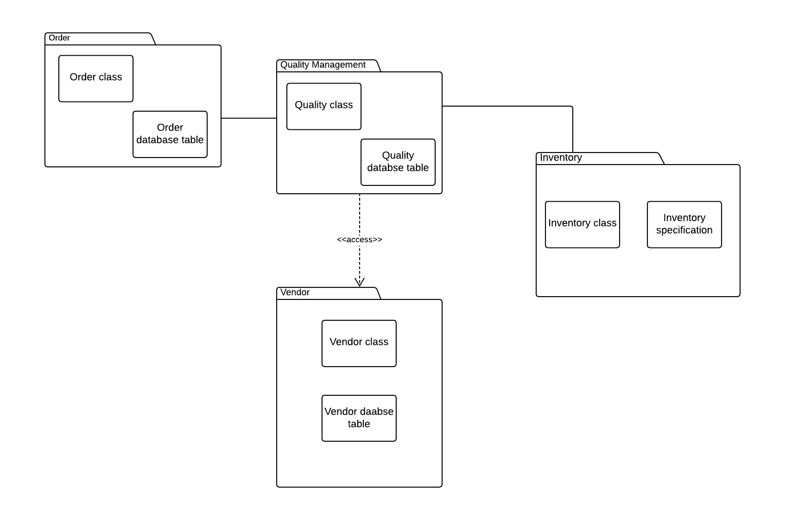

DIAGRAM 8: DEPLOYMENT DIAGRAM

The Quality management node contains controller and tag sensor components. The Transportation interface node manages the transportation system. It contains a work station component. The UI for customer handles all the display board management. It has a server and database components. The Marketing Team node has display controller and sensor component, so that it can show advertisements. They all are connected by a network

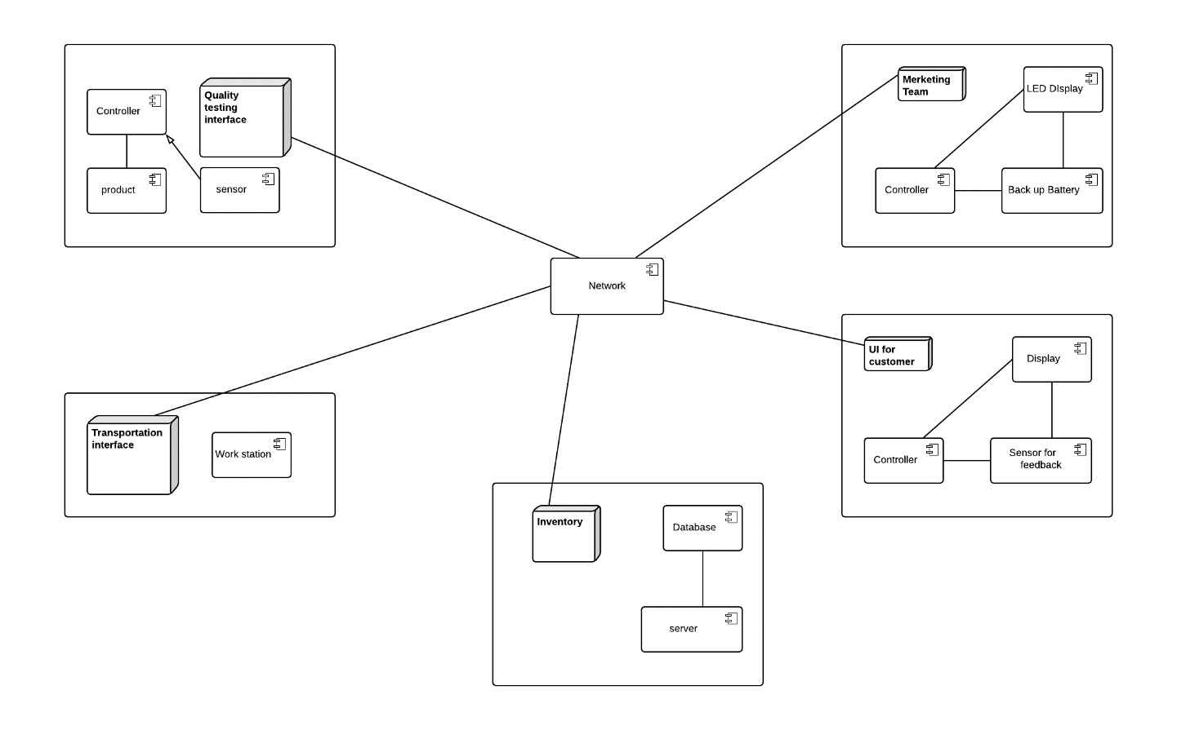

# Entity-Relationship Diagram

The Entity-Relationship Diagram has the entities which are Product, Vendor, Social Media, Quality Management and Online training modules. The feedback entity forms associative entity as it has many to many relationships between Vendor and Quality management team.

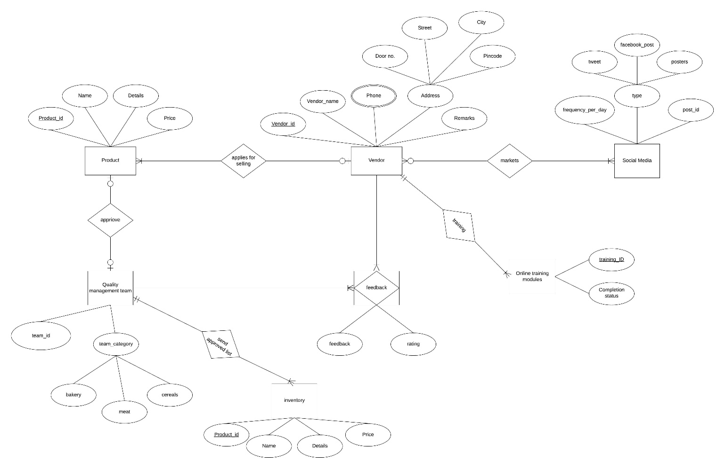

# Wireframes

Note: All the pages are linked to each other and are in sequence in our website.

Below are the wireframes of various pages on our website:

1. **Home Page:**

This page contains a holistic view of everything present on the HEB Vendor Management website. This page is linked to every other page on the website. A user can look at a summary of every event/restaurant/ specialty which DBA has to offer. The user can then click on Login/Signup to go to that page.

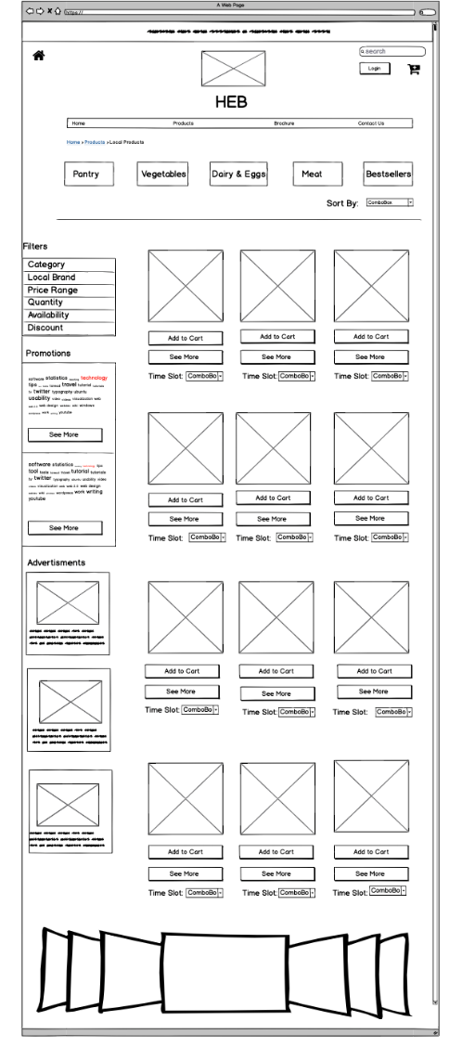

1. **Login/Signup:**

This page consists of two sections – Login section is where an already registered user logins to his/her account. Signup section is where a new user can either use his already existing social media accounts to sign up or enter his own email and password to register as a new user. After both actions are completed the user will be redirected to the home page.

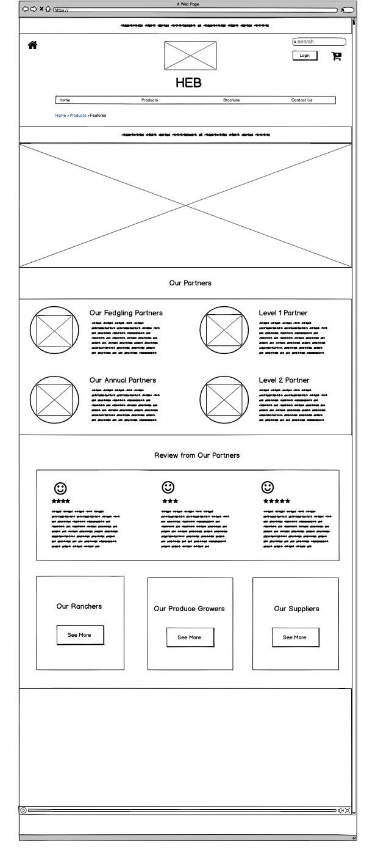

1. **Events:**

This page list all the different events and option to RSVP for them respectively. User can also share these events on their social media pages. Events calendar is displayed which helps the user get a quick view of all days which have an event(s) in a month.

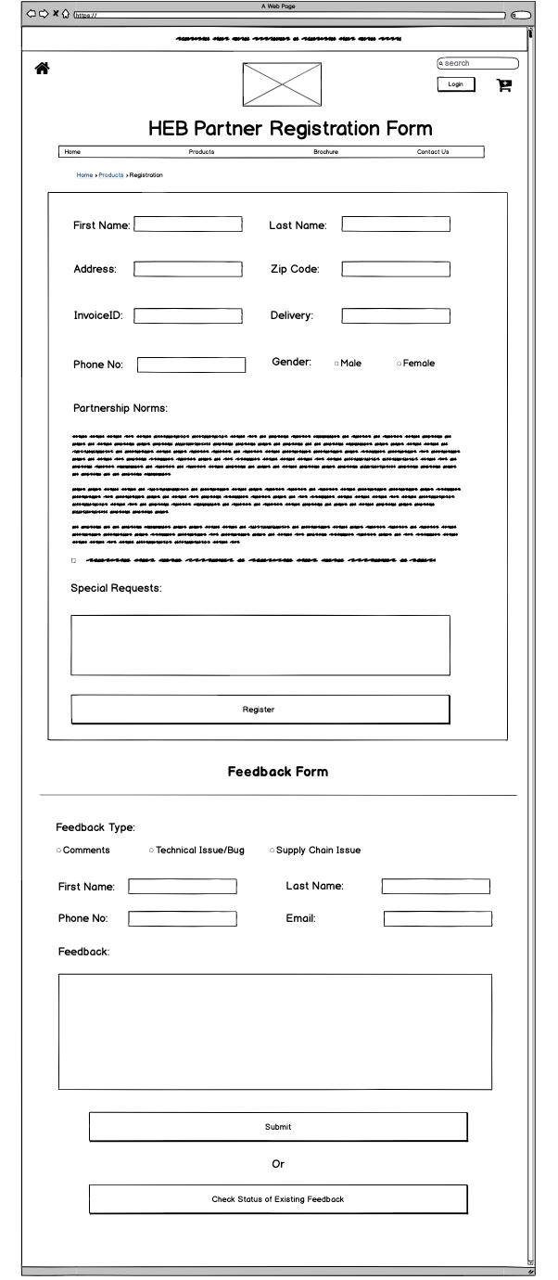

1. **Queen Theatre:**

This page consists of a list of movies and their description. These movies are being premiered in the Queen Theatre. A user can quickly book movie ticket(s) for any movie, on any desired day and time. The user can also pay for the ticket booking and receive a confirmation on his email registered with his/her account.

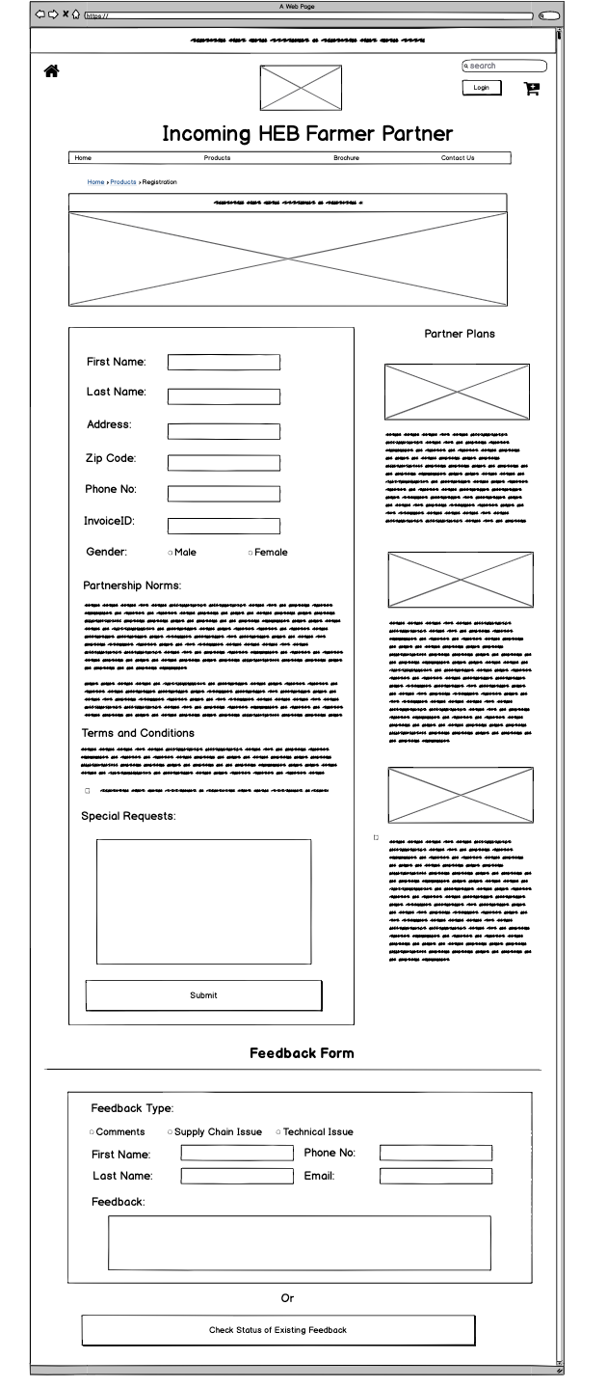

1. **Restaurants:**

This page consists of a list of restaurants in Downtown Bryan and their description. A user can quickly reserve a set in any restaurant on any desired day and time. The user can also receive a confirmation on his email registered with his/her account.

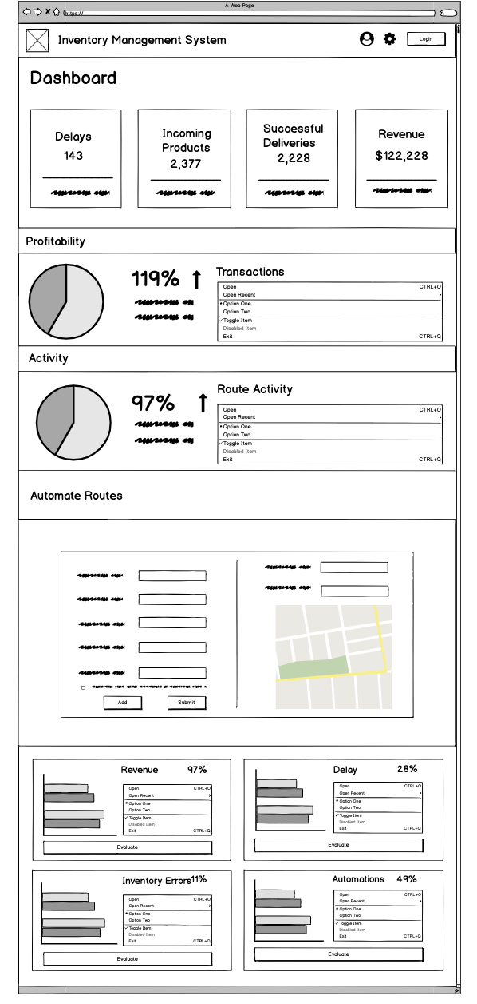

1. **Volunteering:**

This page list all the different volunteering/social events and option to register as a volunteer for them respectively. User can also share these events on their social media pages. Events calendar is displayed which helps the user get a quick view of all days which have volunteering event(s) in a month.

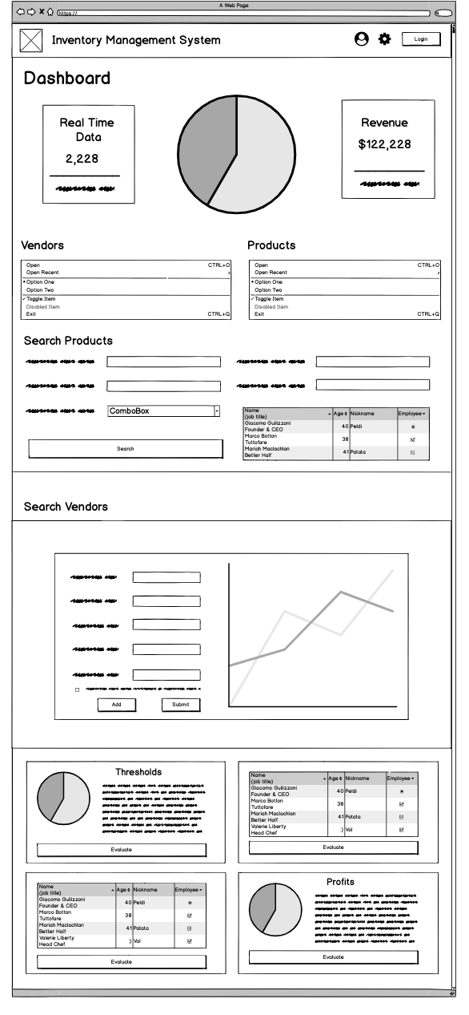

1. **Sponsors:**

This page lists our current sponsors with their logo and link to their respective webpages. The page also has an option at the bottom which can allow a sponsor to look through various sponsorship slabs defined by the DBA and an option to contact the DBA in order to become a sponsor.

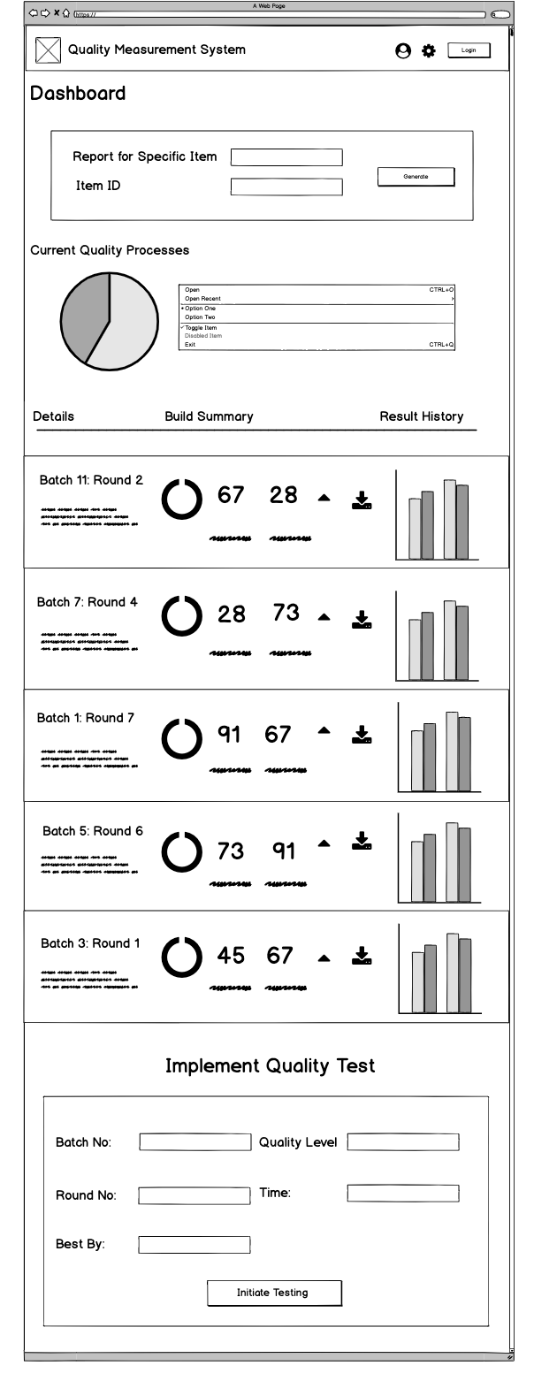

1. **Contact Us:**

This page consists of contact, fax, email and address information of the DBA office. It also has a map embedded on the webpage which displays the location of DBA office. There is a small form at the bottom, which when filled by the user, transmits his/her message and information in an email to a DBA administrator.

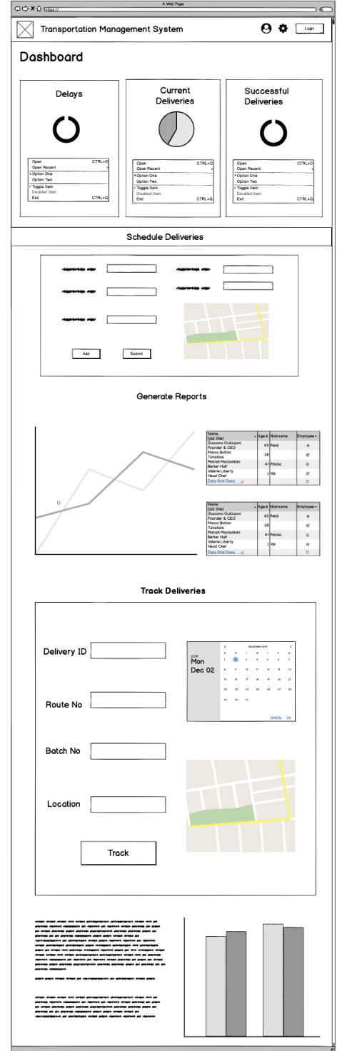

# Mockups

**Restaurants:**

This page consists of a list of restaurants in Downtown Bryan and their description. A user can quickly reserve a table in any restaurant on any desired day and time for any amount of people. The user can also receive a confirmation on his email registered with his/her account.

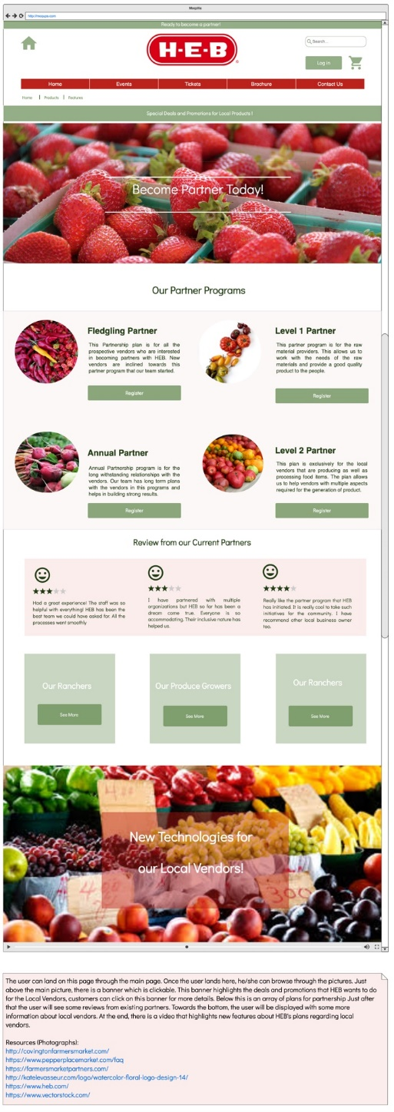

**Contact Us:**

This page consists of office timings, contact, fax, email and address information of the DBA office. It also has a map embedded on the webpage which displays the location of DBA office. There is a small form at the bottom, which when filled by the user, transmits his/her message and information in an email to a DBA administrator.

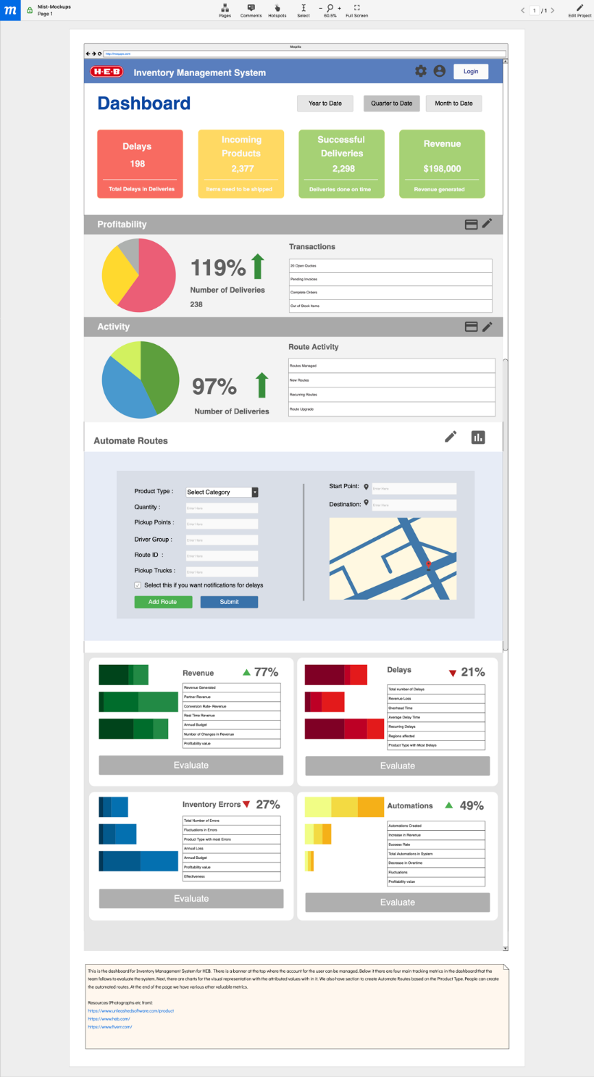

# Project Plan

Project Schedule – September 9th, 2019 to March 6th, 2020

High Level Steps involved in the HEB Vendor Management System project plan:

* **Project Initiation** – September 9th, 2019 to October 11th, 2019
* **Planning/Analysis** – October 14th, 2019 to November 15th, 2019
* **Design/Execution** – November 18th, 2019 to January 10th, 2020
* **Testing** – January 13th, 2020 to February 21st, 2020
* **Project Closure** – February 24th, 2020 to March 6th, 2020

The project plan developed for HEB vendor management is an estimate of when and how the duties will be carried out. The project is about managing various vendors’ products. From taking care of the application by vendors/customers products to sending approval and terms and condition details – the new system will maintain and persist all the tasks. This new system will make the task easier for HEB to expand to new cities and states by applying ease of communication with the help of its new system of chat box where the communication can directly happen with vendors. There will be various inventory management methods implemented such as Just in time, Perpetual inventory, Periodic inventory etc. The system will be customized for each category of vendors from the interface to designated features such as number of plants for a plant seller to the energy unit of tesla charges etc.

The project aims to build the gap between vendors and HEB such that all the vendors have an easier time to list themselves as sellers, get approval for their products and get shipping details and communication with ease. The new system also plans to have forecasting capabilities based on the sell of that particular product in the past.

Ultimately, the tool aims to be simple, effective and easy to use for both the HEB business management people and the customers or vendors.

In this document we will explore some of the milestones, Resources and a plan from initialization to completion of the plan.

Resources:

|  |  |  |
| --- | --- | --- |
| Sr. No. | Name of the Resources | Skills |
| 1 | Sony | Project manager |
| 2 | Joel | Technical manager |
| 3 | Jasmine | Design manager |
| 4 | Jash | Testing manager |
| 5 | Mounica | Lead Developer |
| 6 | Somesh | Testing analyst |
| 7 | Shubham | Database analyst |
| 8 | Jay | Database/Testing analyst |
| 9 | Parker | Programmer analyst |
| 10 | Joe | Testing team member |
| 11 | Peter | Testing and documentation team member |
| 12 | Dale | Programmer analyst team member |
| 13 | Rahul | Data scientist |
| 14 | Avery | Data scientist |
| 15 | Analisa | Testing team member |
| 16 | Sony | Project manager |
| 17 | Joel | Technical manager |

Milestones:

The task of creating a vendor management system has a lot of challenges and milestones which is why it makes sense to delineate clear milestones.

Below are the milestones set up for this project.

Milestone-1: Project initiation

Like in any project we plan to initiate our project with formal hiring and documentation preparation of our stakeholders and clients. This will include project charter that will mark the official starting of the project after the official sign off. Similarly, preparation of Scope schedule is one of the most important tasks. This will be the official documentation for the agreement of what the project is meant to achieve and what is out of the project.

Milestone-2 Planning and analysis

Once the official hiring and project start happens, the planning phase starts. Here we will clearly mention how the vendor management system will be brought in existence from the ground up. The distribution of work and the technology to work on, the duration of time to be spent on each task and so on will be all decided.

Milestone-3 Understanding the existing system

In order to understand the vendor management system of HEB it is of importance to see how the actual vendor management takes place at present, and why the HEB market is low on the other parts of Texas. If there are issues in respect to the existing system that is failing in other states or part of states, then we aim to identify them and improve on them.

Milestone-4 Coordinating vendors and inventory

The task to coordinate vendors and inventory is of utmost importance with increasing number of vendors. Thus, we plan to question vendors about their product so we could customize the user experience for them and at the same time understand the frequency of their product sell so we can manage inventory. In order to achieve maximum feasibility in this we plan to apply machine learning models so we can predict the behavior of the incoming products, products in demand and products which will/will not sell. This might be one of the most challenging milestones and will require a lot of analytics and ML.

Milestone-5 Development of the new system

After all the requirements are gathered, the part of development of software will be tackled by the software developers. The module of vendor management will be in sync with the inventory management and marketing module. The biggest challenge here will be to make features such that teach vendor can get a customized feel and at the same time improves on the existing system.

Milestone-6 Setting up database

Depending on the need and requirement of system a database will be chosen. This DB may be SQL or NoSQL. It may be master slave or peer to peer. This will depend wholly on the type of data and the requirement of operation that is needed.

Milestone-7 Testing and support & documentation

The setting up of system and its implementation will be followed by its testing. There are various kinds of testing that will take place. Once all the test cases are passed the system will be integrated with the existing system and at the same time support and documentation will start which we plan to finish in a span of 3 weeks.

Milestone-8 Sign off

A big and final task will be to get project deliverable sign off. The clients and stakeholders will be grilling a lot before this happens hence, we can expect some delay and backlash here. There is always that something might be a miss, to accommodate that and reaching a consensus, this task itself becomes a big milestone

Project Plan and Gantt Chart - Note: Please zoom in for a better view.

The above Gantt chart shows the estimated time duration of each milestone and category that is expected to take place. Below we will discuss each milestone and resource that is needed for this project. The project is estimated to be completed in 130 days. Within our milestones we plan to tackle challenges such as hitting a moving target, constant

# Sprint Plan

We focus on the implementation phase for our scrum board example. This is our sprint 5 which is running for 2 weeks from December 5th, 2019 to December 19th, 2019. Let’s consider two user stories for which we are implementing the feature in our system.

1. **Regular Visitor**:

He/she wants the feature of being able to look through restaurant options, book a table, receive email confirmations and reminders.

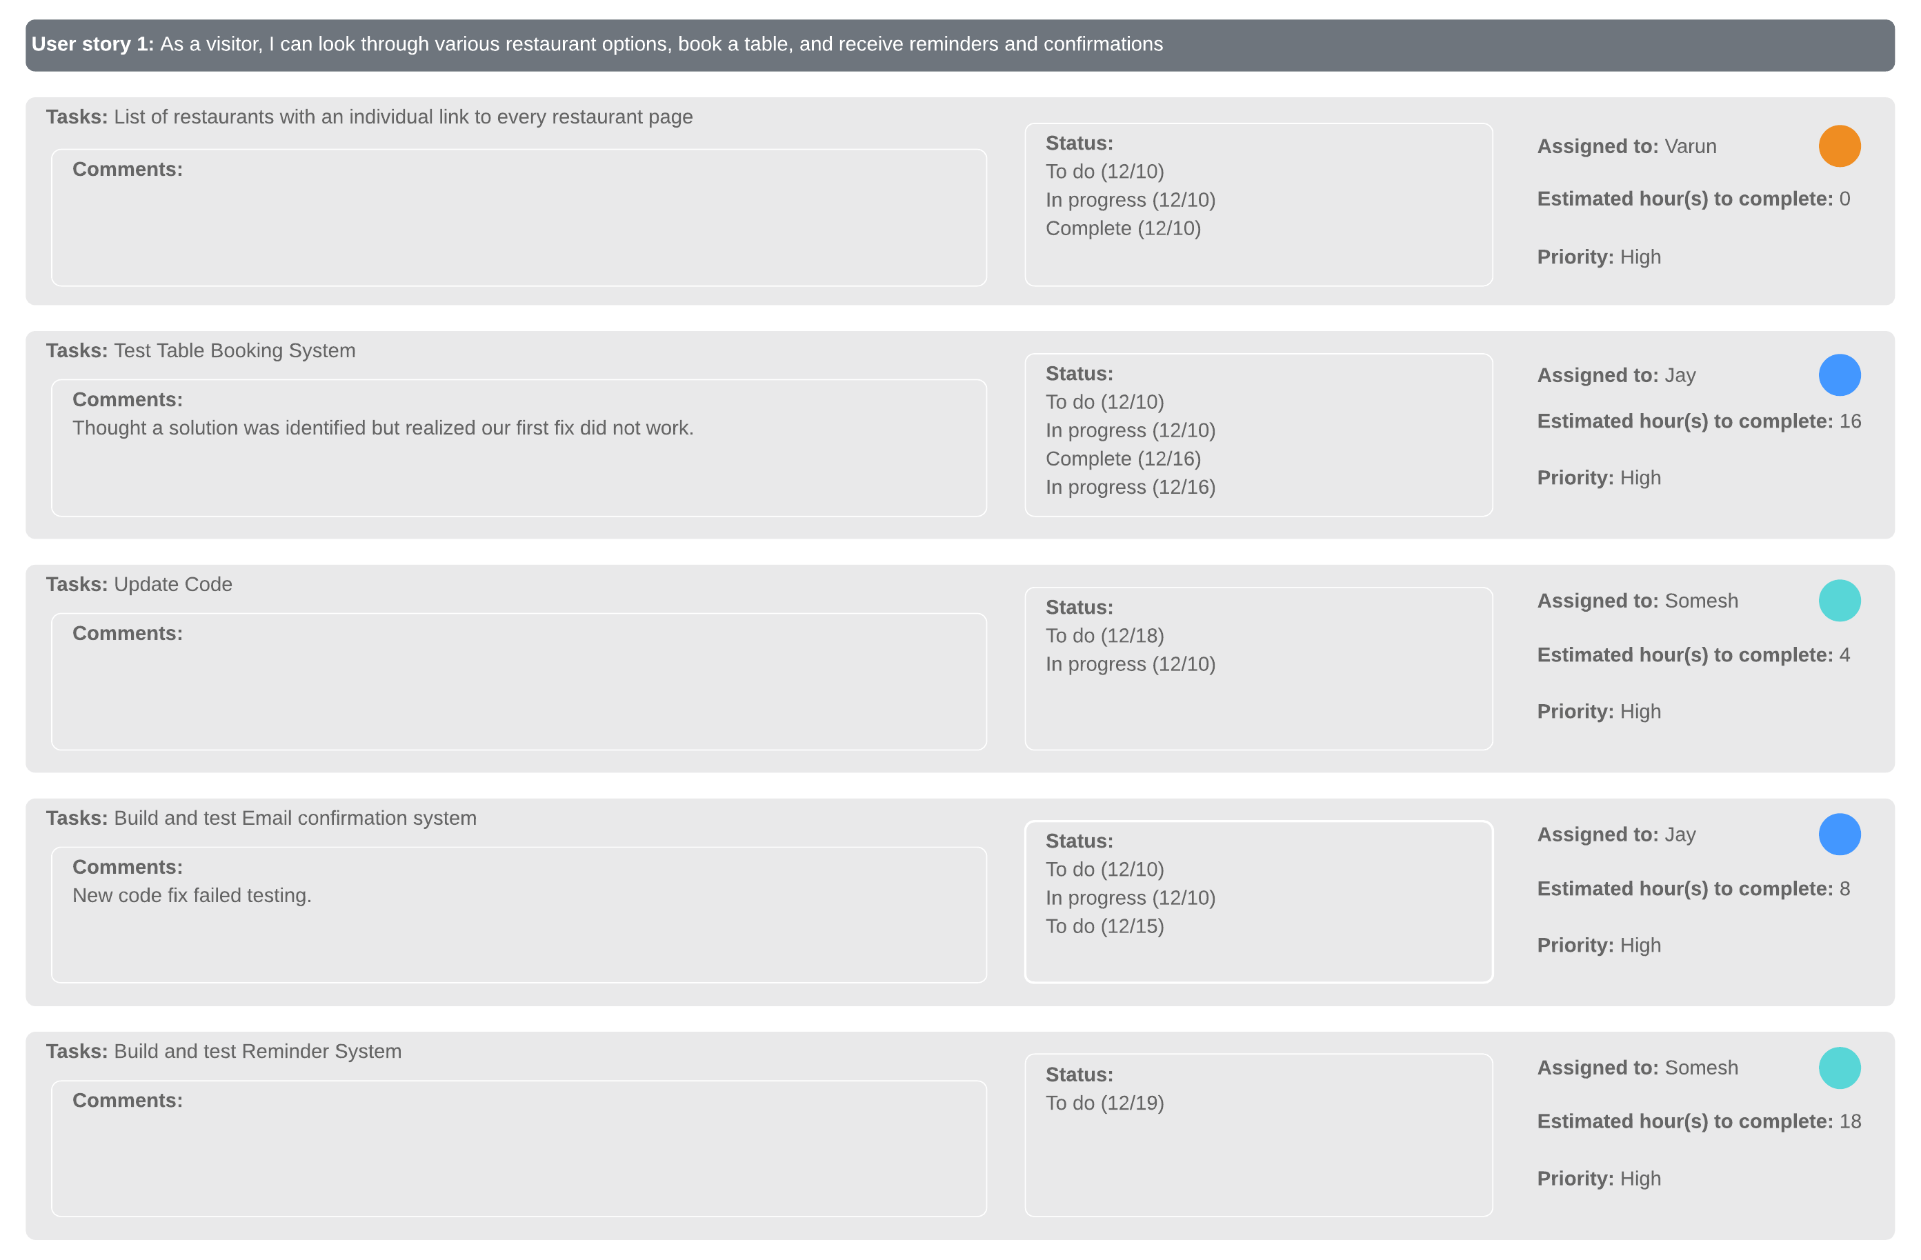

1. **Member of DBA**:

He/she wants to publish events on the website, attract customers, attract sponsors and interact with them

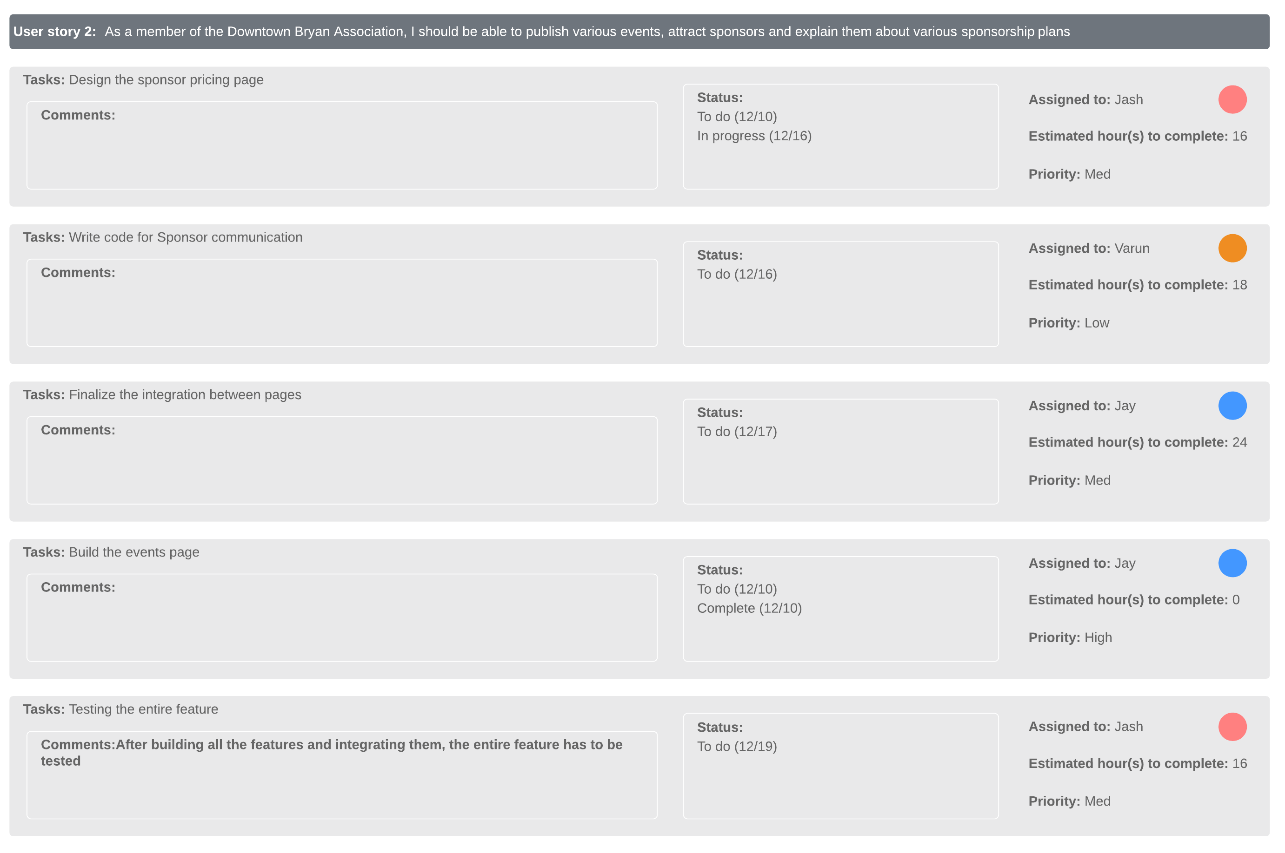

We focus on completing the above two user stories by 19th December before we start with the next sprint.

Scrum Board:

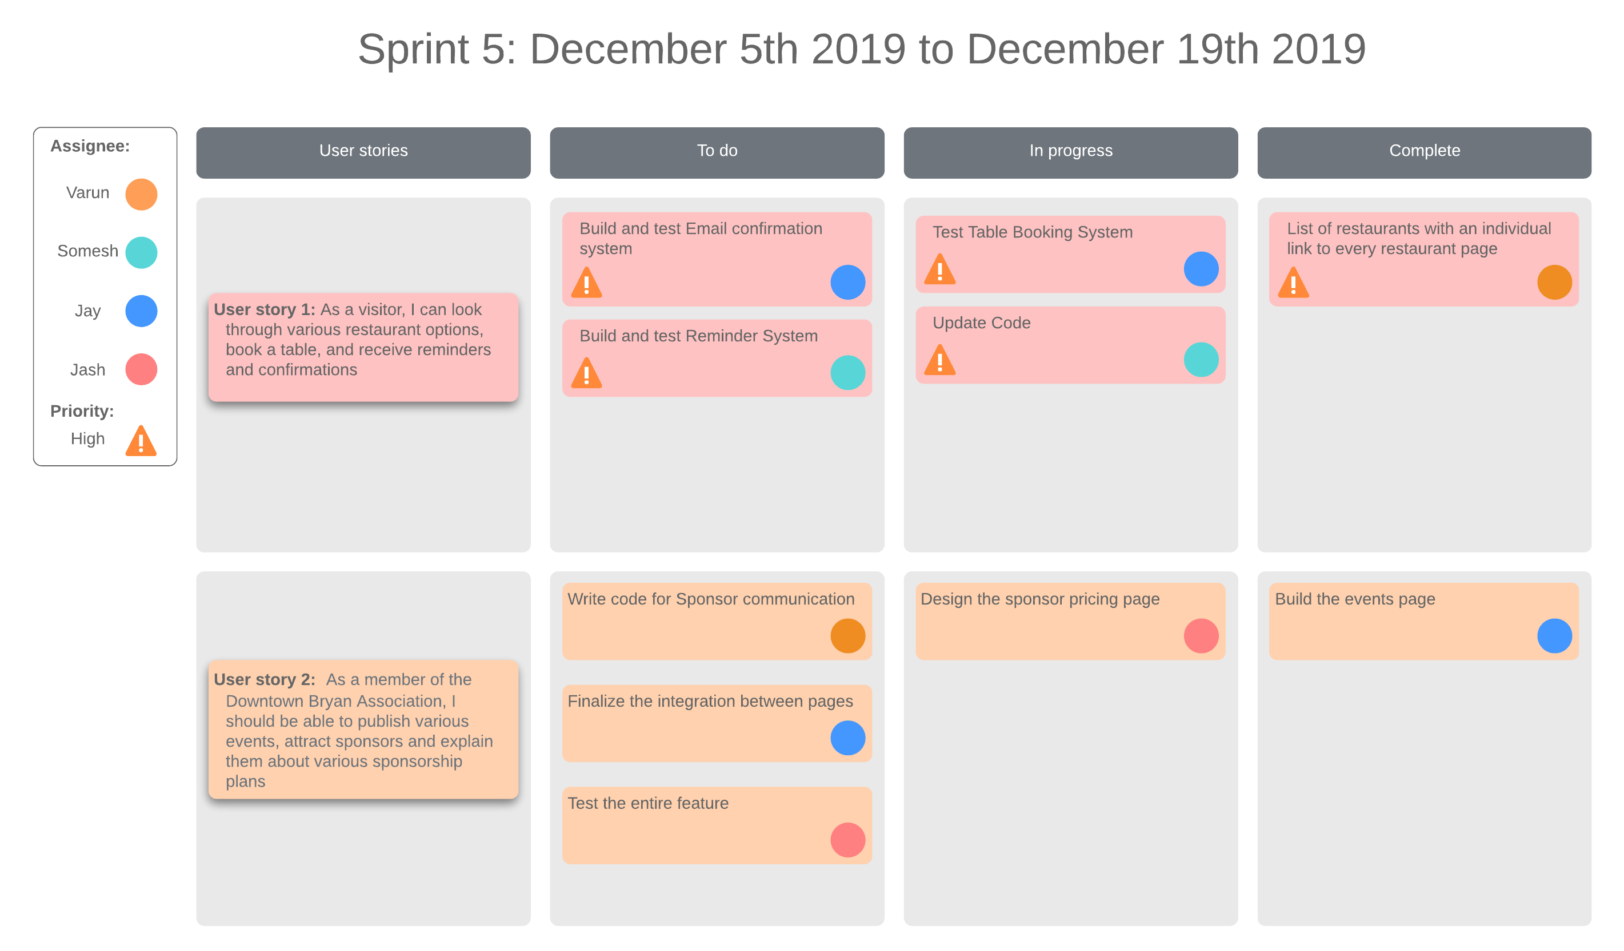

Burndown Chart:

# Implementation Plan

## Introduction/Overview

Purpose

The purpose of this project is to create a vendor management system for HEB and help them expand to various parts of Texas and other states by identifying and understanding the various market regions demands and catering to an improved vendor management system. This goes hand in hand with the inventory management system and will help in ease of communication with vendors, warehouses and help in predict the various trends in terms of what will/will not sell and what will be the future demand.

Assumptions and Constraints

The system will include appropriate software module where vendors can apply for their products to HEB, HEB can have a process to either approve or reject the product, the product can be analyzed for its sold numbers in the past, based on that the vendors can coordinate with the inventory managers and marketing team to market the products to customers and at the same time the HEB services to its vendors. The application of ML will be further added in the future for the HEB to predict the product sell and understand the demand and cost for the same.

## Implementation description

The project will be implemented and deployed in time span of 3 weeks, after which training, and maintenance services will be provided. After the relevant application and interface is developed by the coders, a beta or test version will be released in a particular department

The next step will be to configure all the data and migrate it to AWS servers. The clustering of a RDBMS such as Maria DB will be implemented within a week or so. After that happens the implementation of the remaining ERP systems will not be very difficult

Since this is a mid-level business, the risk of losing service is less as the data will be backed up initially. The user like vendors will be given surety the data will be backed up in AWS servers and their database will be secured. The products advertised will have all the required value before HEB agrees to sell them in their stores which will bring them profit. Once the DB, ERP modules and servers in AWS are implemented the process of deployment will be left with educating the stakeholders the use of system. A proper training will be given to the user for this. This will take another 2 weeks’ time and further 1 year of free maintenance will be provided. The following Gantt chart will give a better picture of what the implementation looks like.

The task of creating a vendor management system has a lot of challenges and milestones which is why it makes sense to delineate. Below are the tasks involved in planning.

## Major rollout tasks & schedule

We plan on adopting a Scrum implementation to execute the new website. This way we can touch upon various user stories and implement a feature related to the user story on our website quickly with a sprint of two weeks each. The Data migration process should take anywhere from 1-2 weeks to fully transfer over all the data and have the new system fully installed and reliable.

Implementation Schedule

The following Project Plan Schedule – Gantt Chart provides the tasks to be accomplish during the project life. Tasks, resources, start date, end date, and constraint columns are provided. The Gantt chart visually explains the schedule of these tasks. You will notice resource names to the side of the horizontal bars. These names represent the specific people who will be working on the particular task on the respective date(s).

The following milestone tasks that must be accomplished by their respective set date are:

|  |  |  |
| --- | --- | --- |
| Sr. No. | Name of the Milestones | Date |
| 1 | Stakeholder Questionnaire Milestone | October 2nd 2019 |
| 2 | Project Charter Milestone | October 11th 2019 |
| 3 | User Stories and UML Diagram Milestone | October 28th 2019 |
| 4 | Project Plan Milestone | November 15th 2019 |
| 5 | System Design Milestone | November 26th 2019 |
| 6 | System Implementation Milestone | January 10th 2020 |
| 7 | Testing Approval Milestone | February 13th 2020 |
| 8 | Feedback Incorporation Milestone | February 24th 2020 |
| 9 | Project Completion Milestone | March 6th 2020 |

Gantt Chart: (Please zoom in for a better view)

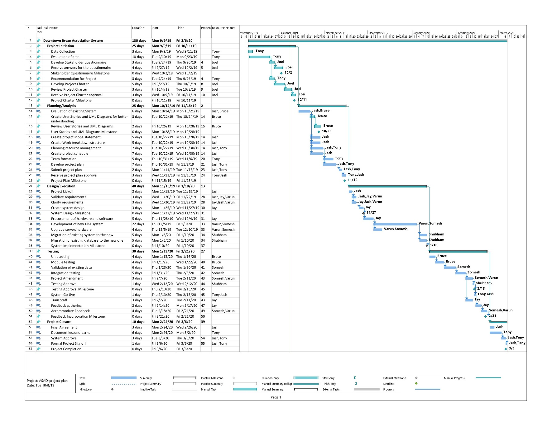

## Pilot Program

A Pilot program will be set up for observing the efficiency of the website from a user’s perspective. It is very important to realize if the website created will be user-friendly, concise, simple and understandable from a user’s way of operating. Pilot Program will mainly aim at answering these questions. Our pilot program will consist of the following steps:

1. Deploy the website on a trial domain
2. Users’ Selection
3. Training Video
4. Test Website
5. Gather user’s feedback

Deploy the website

We need to buy a trial domain to deploy our newly made website which will be open for user access. We need to test the deployment on our end to ensure everything is running smoothly.

User Selection

Based on the users’ data from the previous website, we can focus on the most frequent users of the old website. These seem to be the people who are most interested in downtown Bryan. We need to select around 50 users who will use the new website and test the various features.

Training video

A training video will be sent to the selected users, explaining the details of the new website, showing off the different features and how to use them.

Test Website

A period of 2 days will be allocated for the 50 users to thoroughly test the website and various features end to end. Meanwhile, as the users use the various features, the backend will be tested by our team.

Gather user feedback

A detailed user feedback form will be sent to the users. They need to fill out the form based on their experience and understanding of the website and even provide feedback for improvements and ratings on various features. This feedback will be collected, analyzed and changes will be made to the website to make it more user-friendly if required.

## Training plan

Various training session will be organized once the system is in place. The training will take place for the duration of 3 weeks in which the upper administration is trained first and then trainers are trained. The trainers can then in-turn train the lower level staff members. The end user will be trained via online portal of SKILLME, this is a third-party portal that will have organized pre-shot content from us. All resources like documentation and online learning videos will be available in the repository.

Week-1

The administrators and upper level manager will receive a direct in person session with the developers and the technical expert who can indoctrinate them on the implementation of system, features, possible risks, outages, overloading of traffic etc. The trainers will also be trained on the usage of the system and features like how to communicate on the shared interface with the customers, job seekers, parking lot managers, and sponsors using the same software and how to deal with system outages and resolve server errors.

Week-2

Week two will be about teaching the employees about the system installed. Here the trained trainees will disseminate knowledge via short sessions on various topics and modules of ERP system such as tax, schedule, ticket issues, etc.

There will be various documentation and videos available with the help of SKILLME and developer’s documentation explained in simple terms.

Week-3

Here a reflection or reverse knowledge transfer session will take place for all the employees including the supper level management. Since this is a mid-level business it will not be as difficult to indoctrinate the employees, hence a reverse in person KT session will solidify the knowledge. Moreover, documentation related to resolving possible server errors will be handed over and online SKILLME sessions will be shared. Some of the topics covered would be as follows:

1. Successfully inputting data and receiving outputs
2. Inputting invalid data and receiving error message
3. Common errors and ways to correct them
4. How to import and export data
5. Command sequences required to perform specific functions
6. Program functions required to implement specific business procedures
7. Back-up procedures
8. Accessing backup DB server
9. Safe system start-up and shutdown
10. Scaling of servers in the future

.

## Discussion of user documentation

Documentation is perhaps one of the critical aspects that is taken very lightly and often never done properly. However, we have a detailed plan of documentation of out projects. This will cover all the documentation from ERD diagrams to module specific documentation with feature, risks etc.

Topics to be included in documentation/ user guide:

* 1. **Stakeholder identification:**

This will contain the name and the level of importance of a stakeholder. The topic will contain how the stakeholder can influence the project. This will also contain personal info such as likes and dislikes of the stakeholder.

**Format: online**

* 1. **Project Charter:**

This will contain the goals, resources, expectation, requirement of the project and will act as an official sign off for the beginning of the project. The document will contain all the people who can be contacted when there are various kinds of emergencies.

**Format: online, print**

* 1. **Budget:**

This document will contain where all the expenditure can happen. From the salaries of employee to the auxiliary cost that might occur, all will be included in the Budget. Here the possibility of extra money loss will be taken and provided to user.

**Format: online, print**

* 1. **Gantt Chart:**

This document will contain a detailed analysis of timeline of when what project milestone must be achieved and who will take various responsibilities. From project charter to development to code to project sign off all duties are written here with the timeline and the person responsible.

**Format: online**

* 1. **ERD:**

One of the most important documents is the ERD of the system. This will not just help in understanding the full implementation of the project but also help in future references in case something in system need to be changed.

**Format: online, print**

* 1. **ERP Implementation:**

A full documentation on ERP implementation will be given and how the various modules are interacting with each other. This will include various features each module includes, their implementation their risks and resolutions.

**Format: online**

* 1. **Risk management:**

This will be a dedicated document on various kinds of risks that the system might be susceptible to and how to deal with them in case any such thing happens. The first steps towards security and recovery and future guidelines.

**Format: online**

* 1. **Database implementation**:

The document will contain detail implementation steps for AWS servers, what sort of DB is used, why and the potential risk and helpline in case anything goes wrong. This will further contain steps that will guide on future management of risks.

**Format: online**

* 1. **User training:**

The document will contain all the user training material from SKILLME and other sources that will be only in digital format. The training for AWS, Ticketing system, Communication system, Network system, Features etc.

**Format: online**

* 1. **Approval:**

This document will contain various stakeholder’s approval after all the system and features are implemented and understood by the stakeholder. An official sign off document will be a proof of requirement fulfilment.

Format: online, print

## Transition from implementation to long term support

A smooth transition from Implementation to long term support is of utmost important in any IT project. We will deal with this transition in steps or in breaks. A requirement of long-term support starts when the need for constant resolution of issues is realized or when the development team spends more of their time in resolution of same issues rather than developing of new code.

Some of the significant aspects are:

Dedicated transition leaders: There will be specific leaders responsible for transition of the project from implementation to support. The process will include hand offs and official approval from the stakeholder.

Documentation: The transition team will prepare specific documentation to help understand the technical insights for the system. Transition duration: The duration of the transition will be 3weeks.

The support for the ERP system will be extended to 3 extra weeks depending on the situation. The dedicated team in addition to 3 developers and 2 testers will support the employees of Queen theater to understand the ERP system in place.

Since this is a small business the tech support can be extended to employees and to the customers for 3-4 weeks extra on request. Once the application is in place and the website is developed both the front end and backend. After that the developers and testers for some particular amount of time will take up bug fixing and the issues that might come along for around 6 months.

A call helpline will be set-up to support the possible glitches that might come along the way. This will be monitored by an in-person employee and will work towards immediate solution. This is set up since the business is mid-level and not as many issues are expected to arise.

Below is a summary of tasks that will be monitored while transitioning from development to support:

|  |  |
| --- | --- |
| **Category** | **Transition** |
| Application  development | The transition to application support will be extended to 3 weeks after the official sign off of the project. The task will be supervised by designated team for transition. The employees of queen theatre will be indoctrinated on the usage of application and website equally. |
| AWS server | The team of data engineers who worked on the implementation of these servers will help in explanation of the documentation via various sessions. These engineers will help in giving KT to employees and extra support for 1 week after official sign off |
| ERP Modules | The support for ERP will be delivered after the implementation is done and will be extended to 6 months after official sign off. The staff with educate the employees on the various modules that they are supposed to use such as integration management, inventory management etc. will have session on tax module and vendor/sponsor management team will get session on their particular module. |
| Website | The website support will start immediately after the website is live after all the features are confirmed and approved. The development team will support the employees with the sessions and documentation that would teach them the features. The support for this will be a month long will commit to CMS, link and various front-end issues |
| In person helpline | To coordinate the issues and ticket them some people will be trained to telephone the calls log in the correct request in the system at the right place. Training on this will be given and support on the methodology will be provided 3 weeks after the sigh off. |

Reaching out to the correct people in the case of error and emergency is of utmost importance. Below are the contact name, designation and emails of the people from the company that can be reached for issue with particular domain.

# List of Contacts

|  |  |  |  |  |
| --- | --- | --- | --- | --- |
| Sr. No. | Category | Designation | Email | Contact |
| 1 | Application issue | Project manager | [Rsoni13@heb.com](mailto:Rsoni13@heb.com) | 551-263-2944 |
| 2 | Website issue | Technical lead | [joel@heb.com](mailto:joel@heb.com) | 551-263-2944 |
| 3 | Documentation | Test lead | [monica@heb.edu](mailto:monica@heb.edu) | 221-263-2933 |
| 4 | AWS servers | Asst. project manager | [jasmine@heb.edu](mailto:jasmine@heb.edu) | 331-263-2944 |
| 5 | Network issue | Team member | [FaithC@heb.edu](mailto:FaithC@heb.edu) | 551-263-2955 |

For any other general issue or queries the helpdesk number 666-234-2211 can be reached, and a vice message can be dropped off. Moreover, for a general issue or problems a mail could also be dropped off at the email ID HEBNorthAmericaSupport@heb.com